
FATIMA JINNAH WOMEN UNIVERSITY
RAWALPINDI
Department Of Software Engineering

Cloud Computing Lab
Saira Ejaz [2023-BSE-057]
Section: 5-B
LAB NO 13
Task 0 Lab Setup (Codespace & GH CLI)
- task0_codespace_create_and_list.png
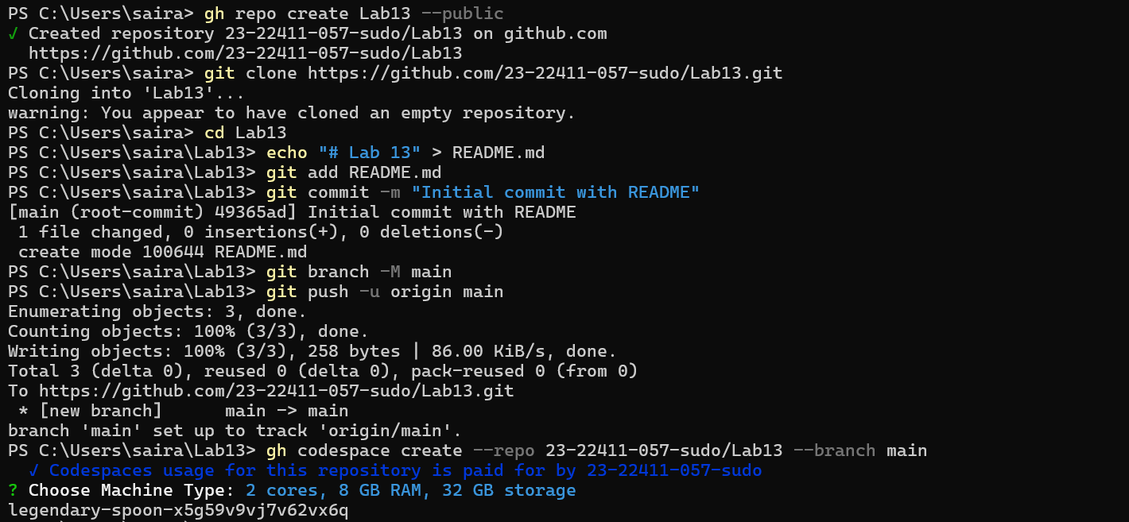
- task0_codespace_ssh_connected.png
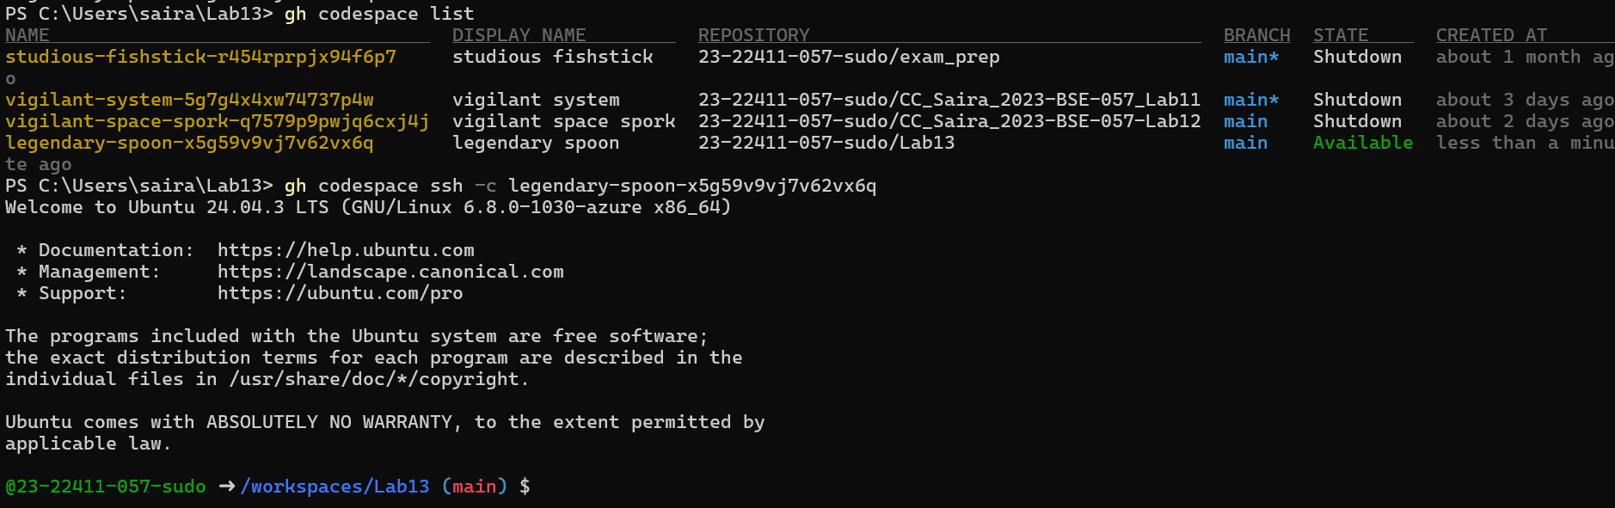
Task 1 — Create IAM Group and Output Details
- task1_project_directory.png
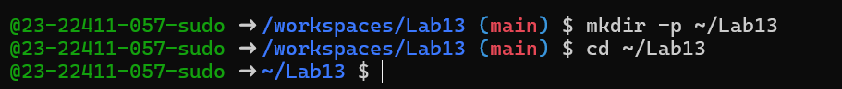
- task1_file_created.png
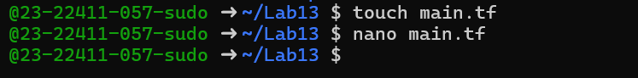
- task1_main_tf.png
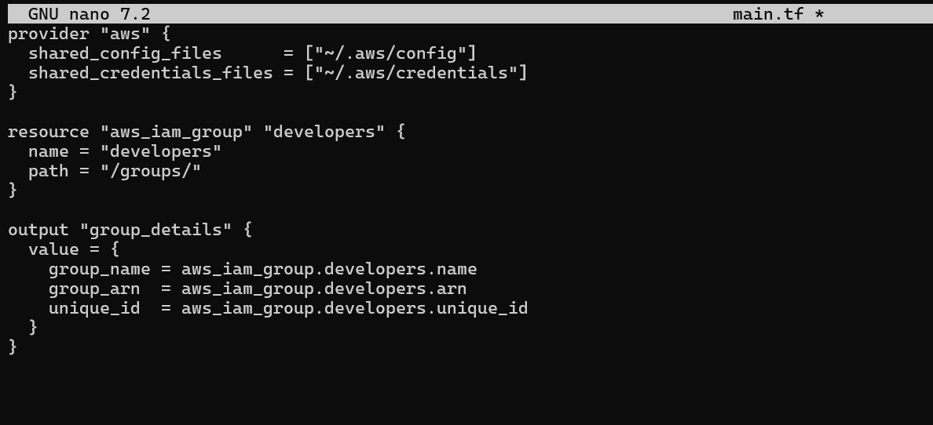
- task1_terraform_init.png
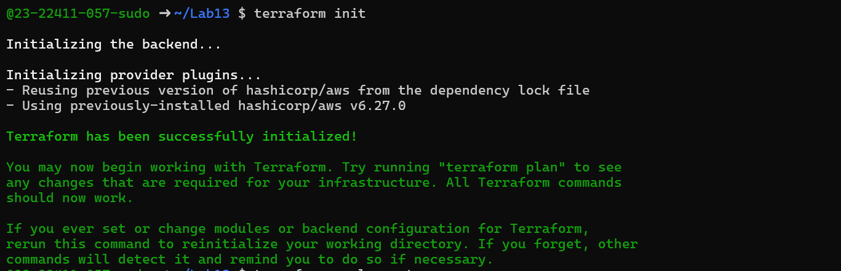
- task1_terraform_apply.png
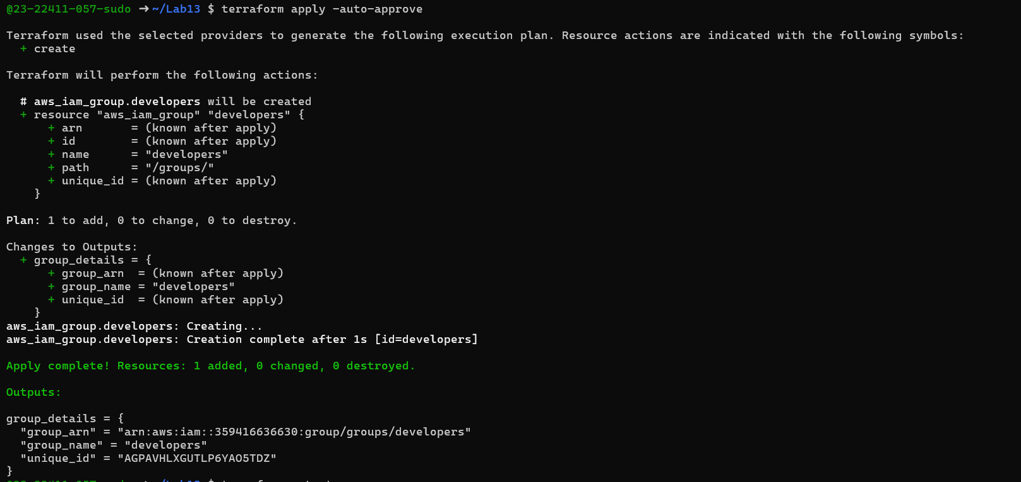
- task1_terraform_output.png
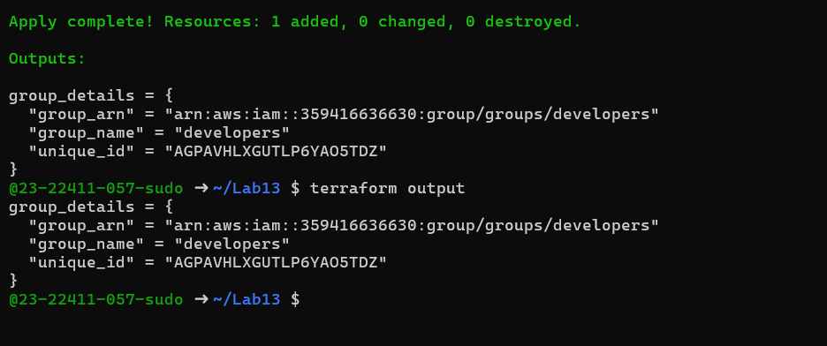
- task1_aws_console_group.png
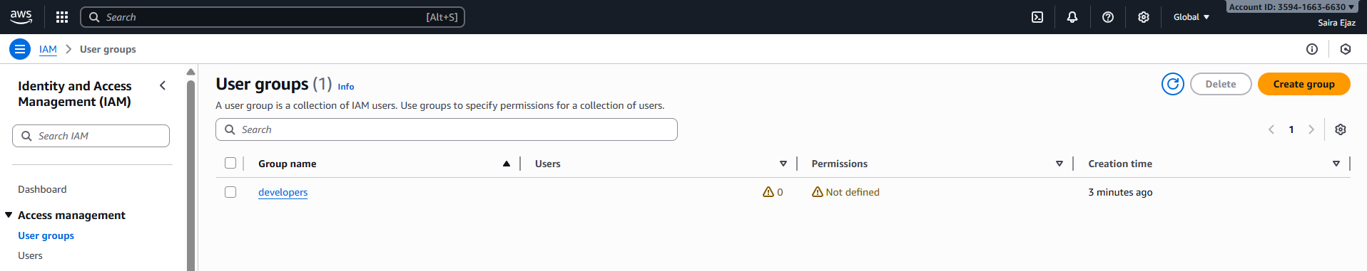
Task 2 — Create IAM User with Group Membership
- task2_main_tf_user.png
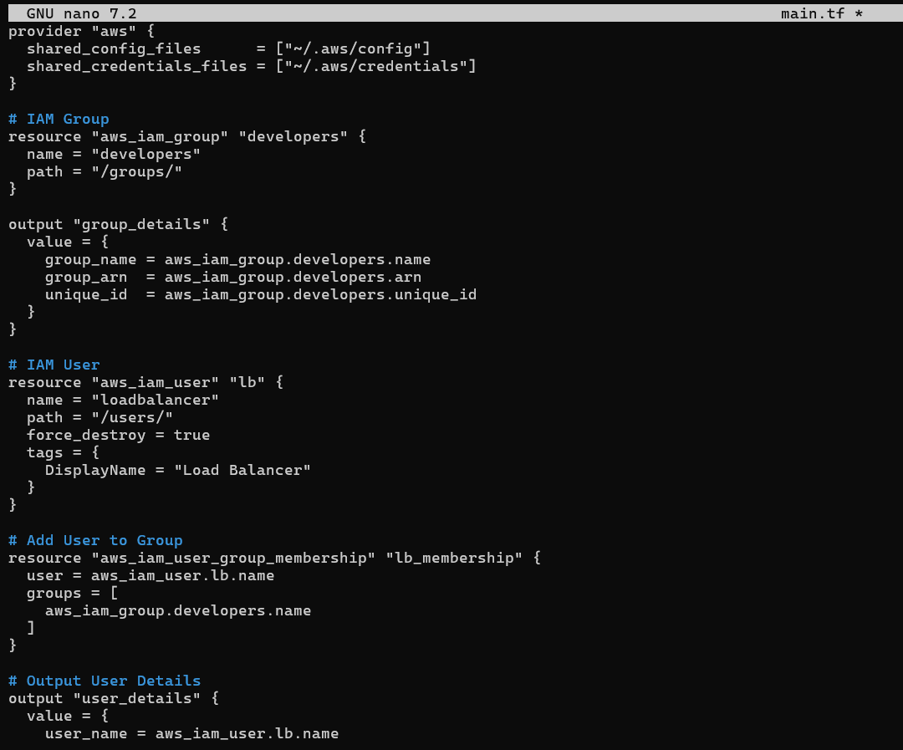
- task2_terraform_apply.png
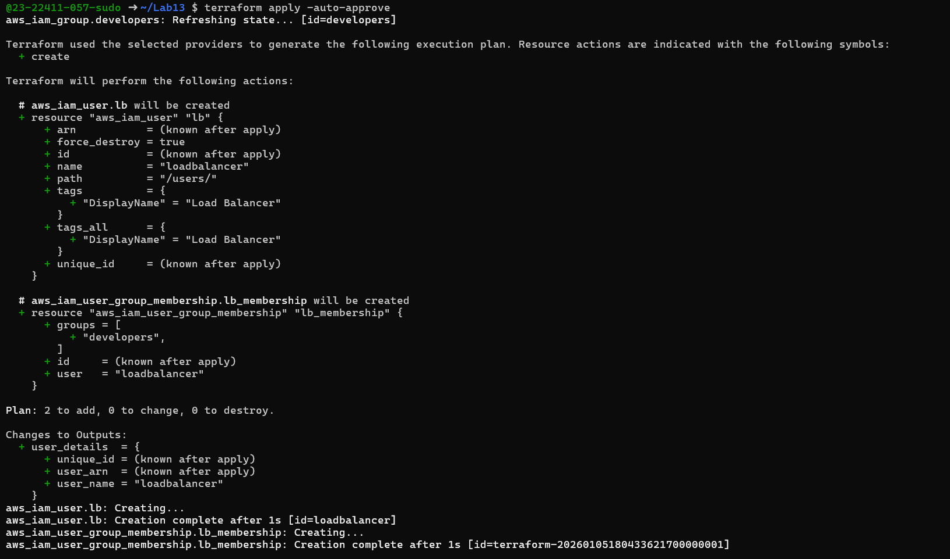
- task2_terraform_output.png
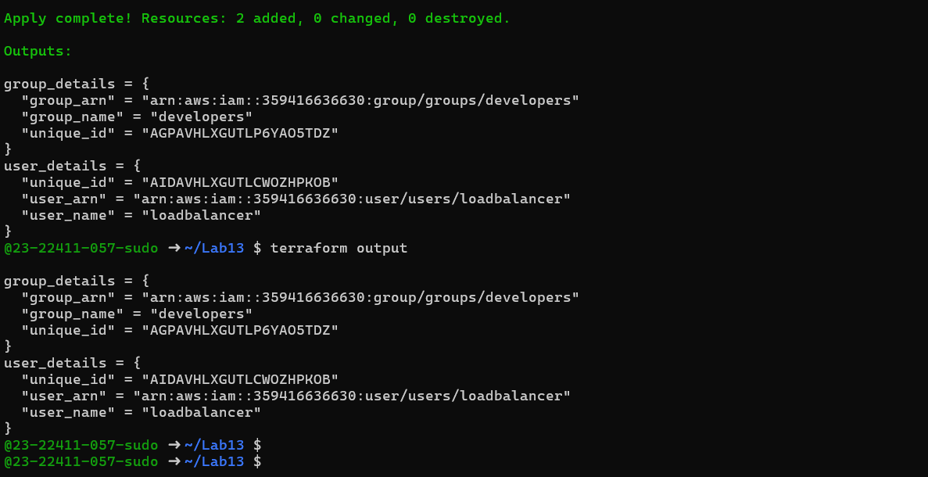
- task2_aws_console_user.png
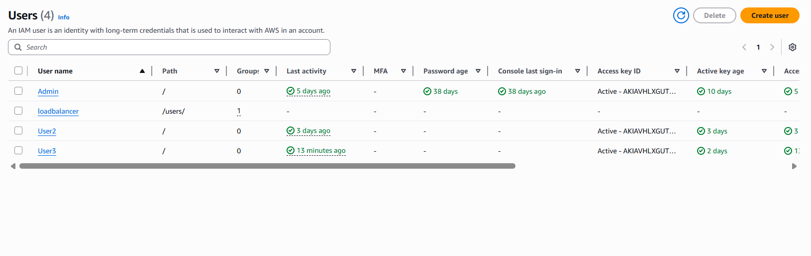
- task2_aws_console_user_groups.png
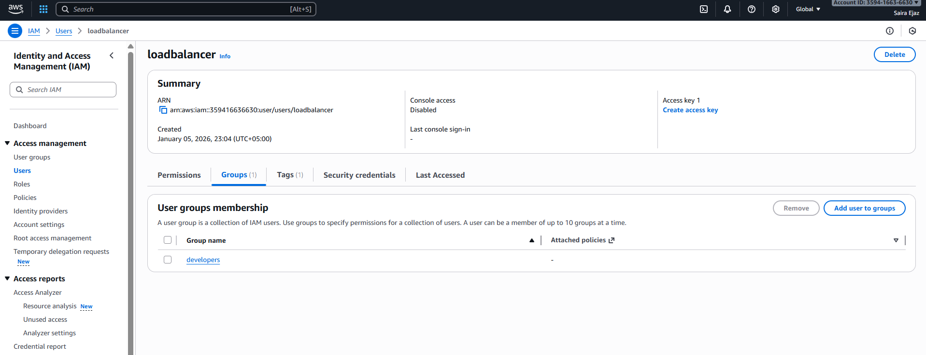
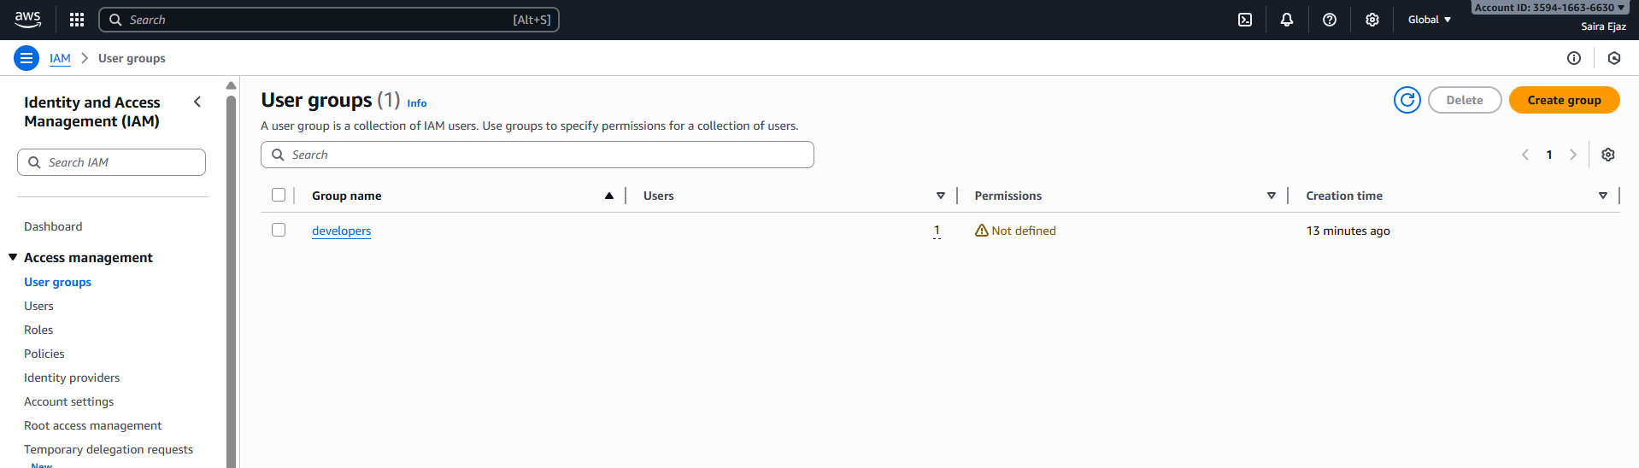
Task 3 — Attach Policies to IAM Group
- task3_main_tf_policies.png
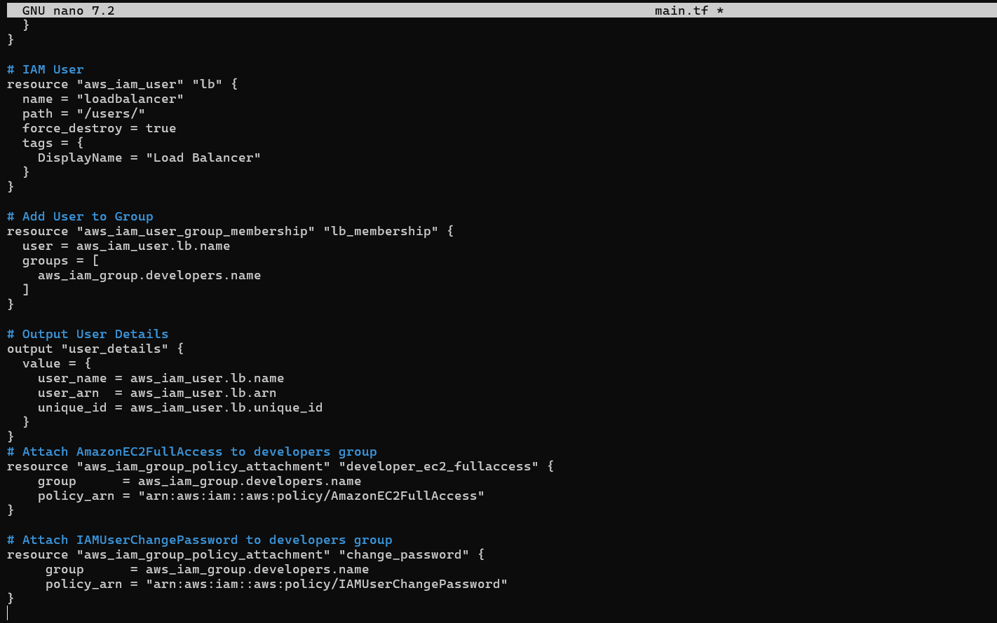
- task3_terraform_apply.png
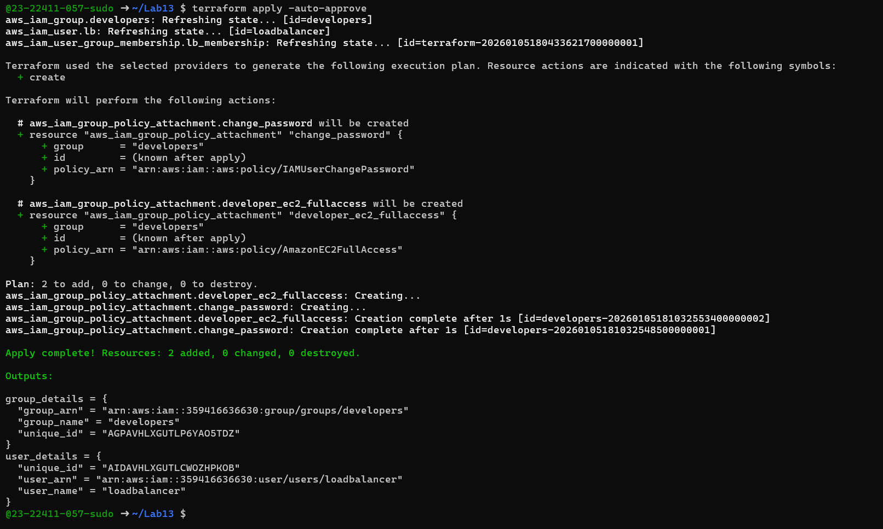
- task3_aws_console_policies.png
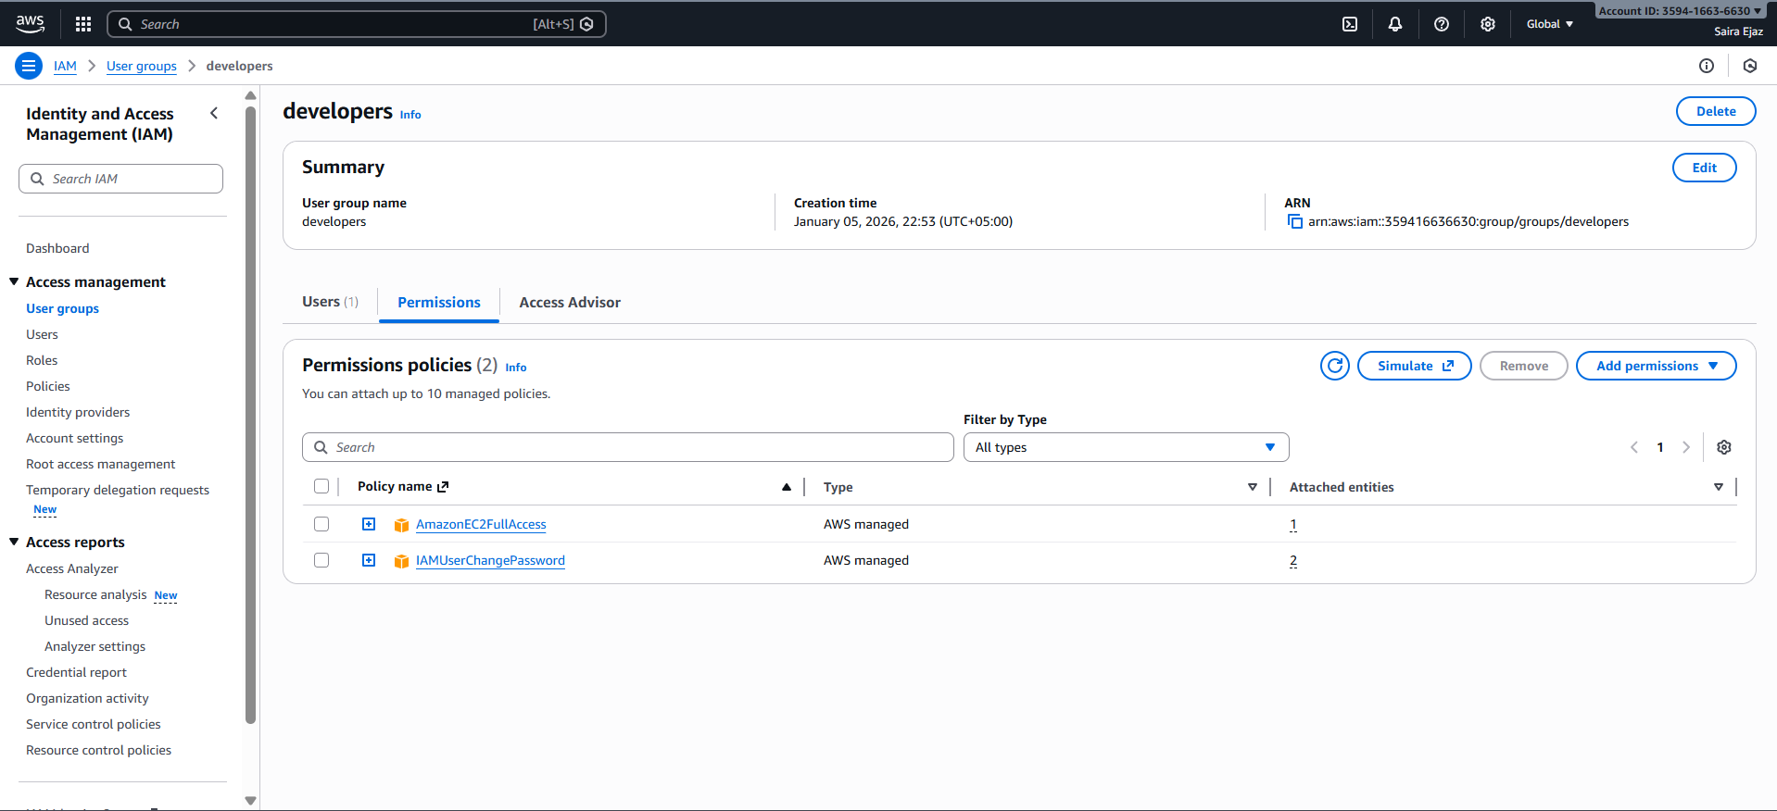
Task 4 — Create Login Profile for IAM User
- task4_variables_tf.png
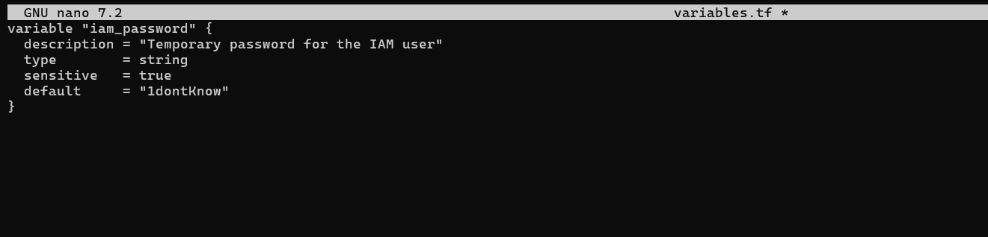
- task4_create_login_script.png
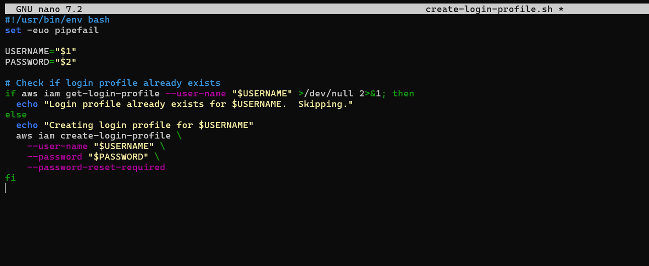
- task4_chmod_script.png
- task4_main_tf_login_profile.png
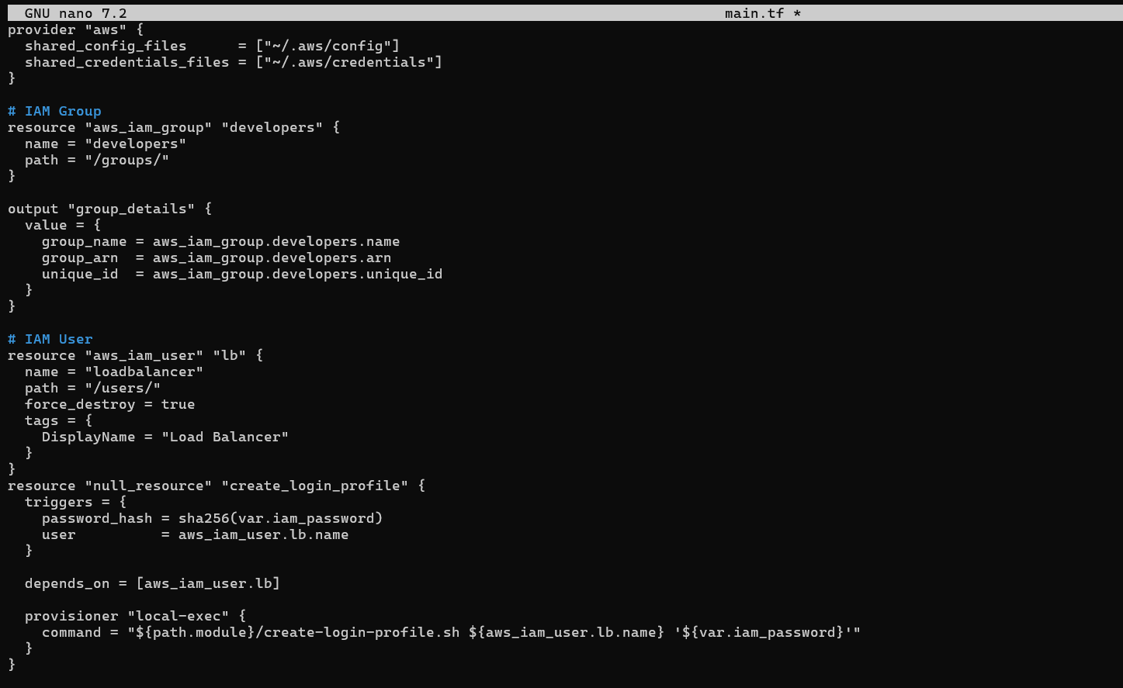
- task4_terraform_apply.png
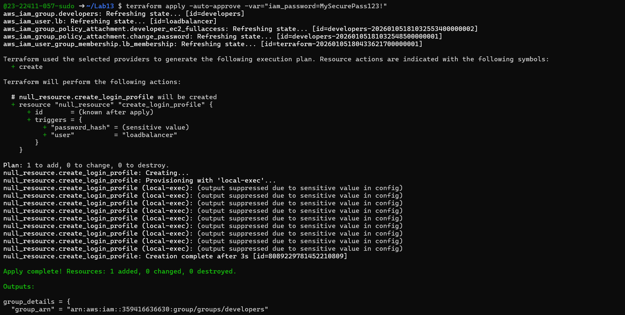
- task4_aws_cli_verify.png
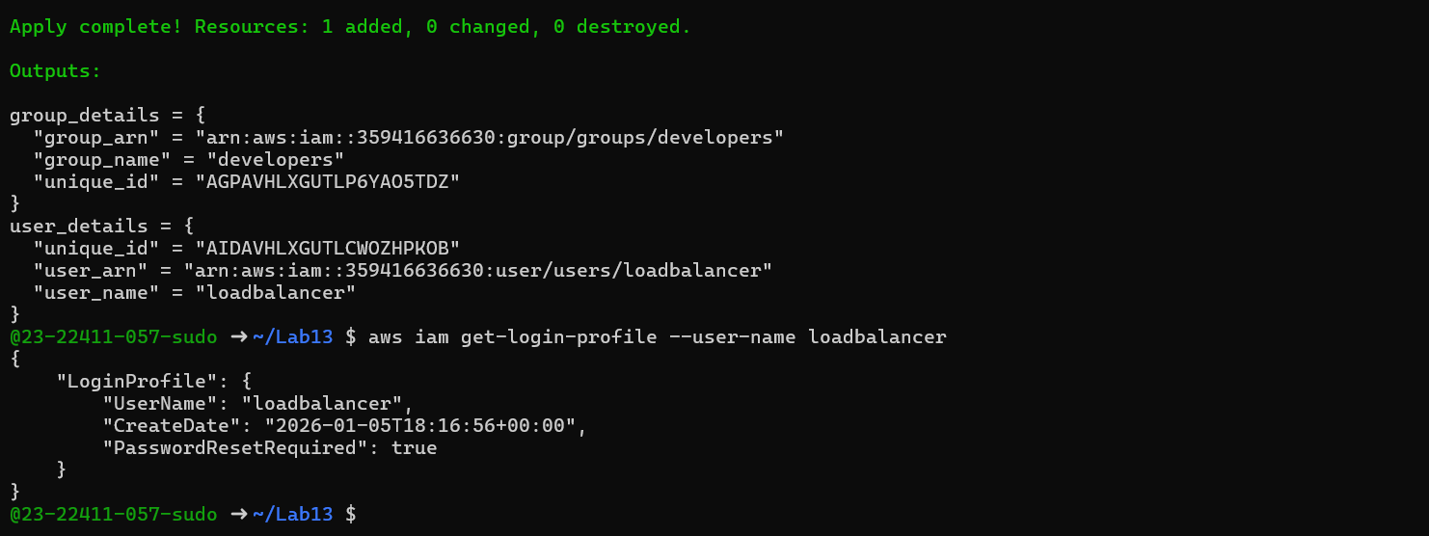
- task4_aws_console_login.png
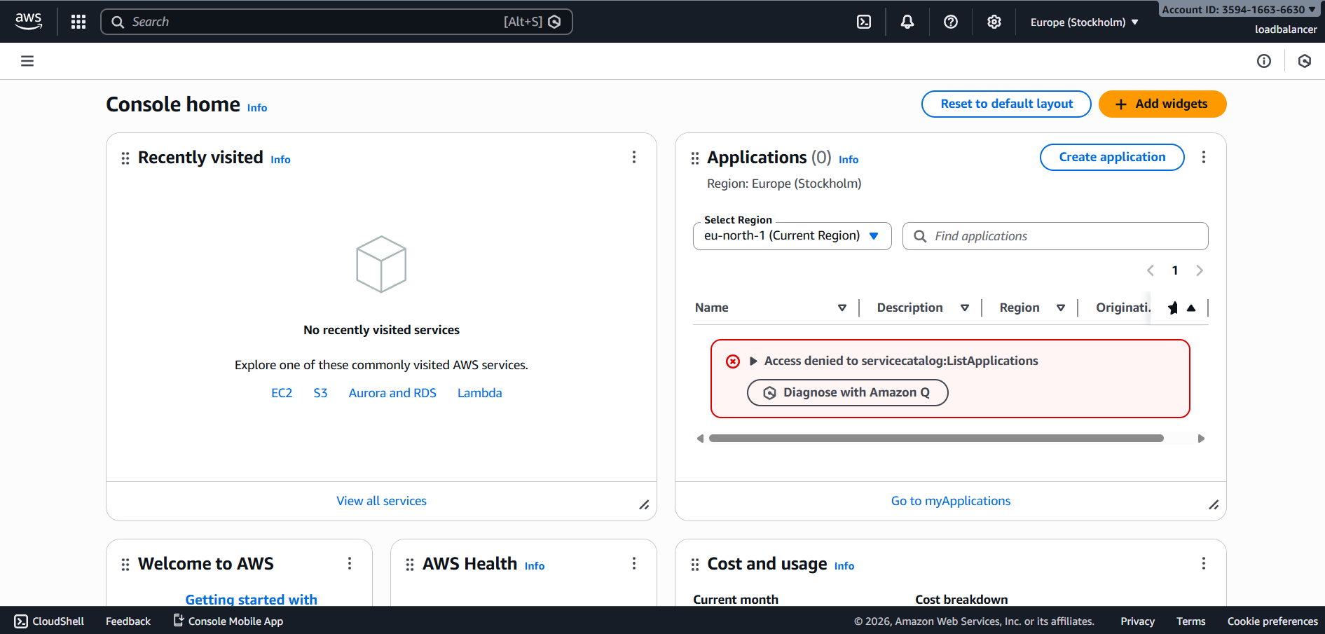
- task4_aws_console_password_reset.png
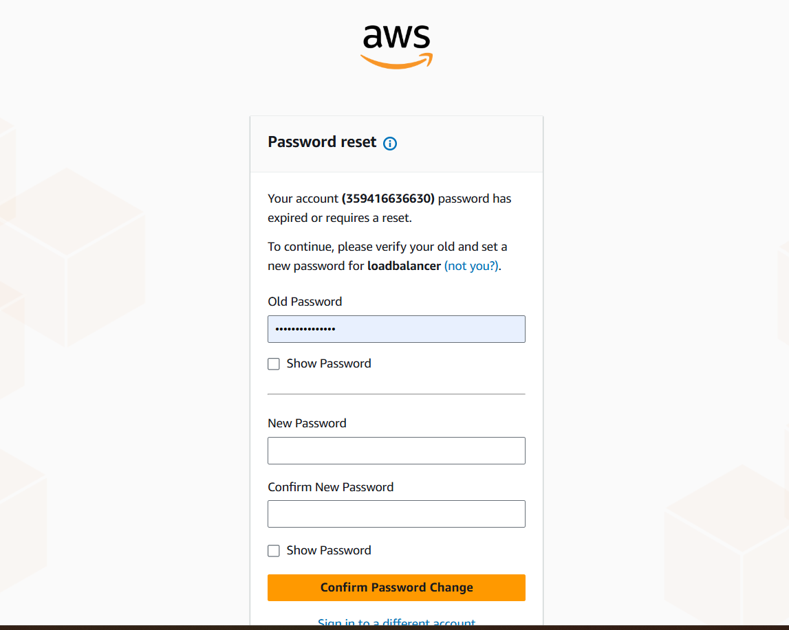
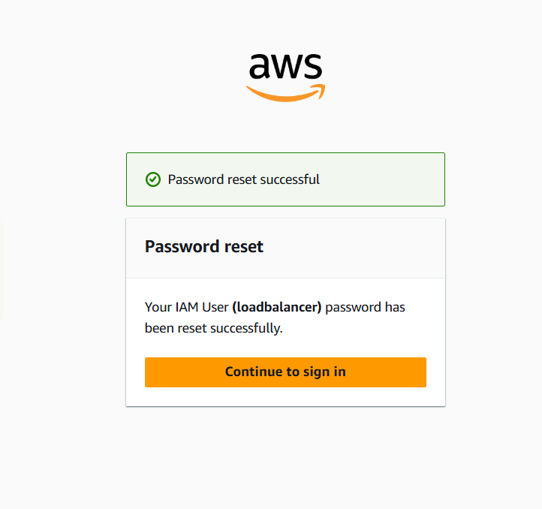
Task 5 — Generate Access Keys for IAM User
- task5_main_tf_access_keys.png
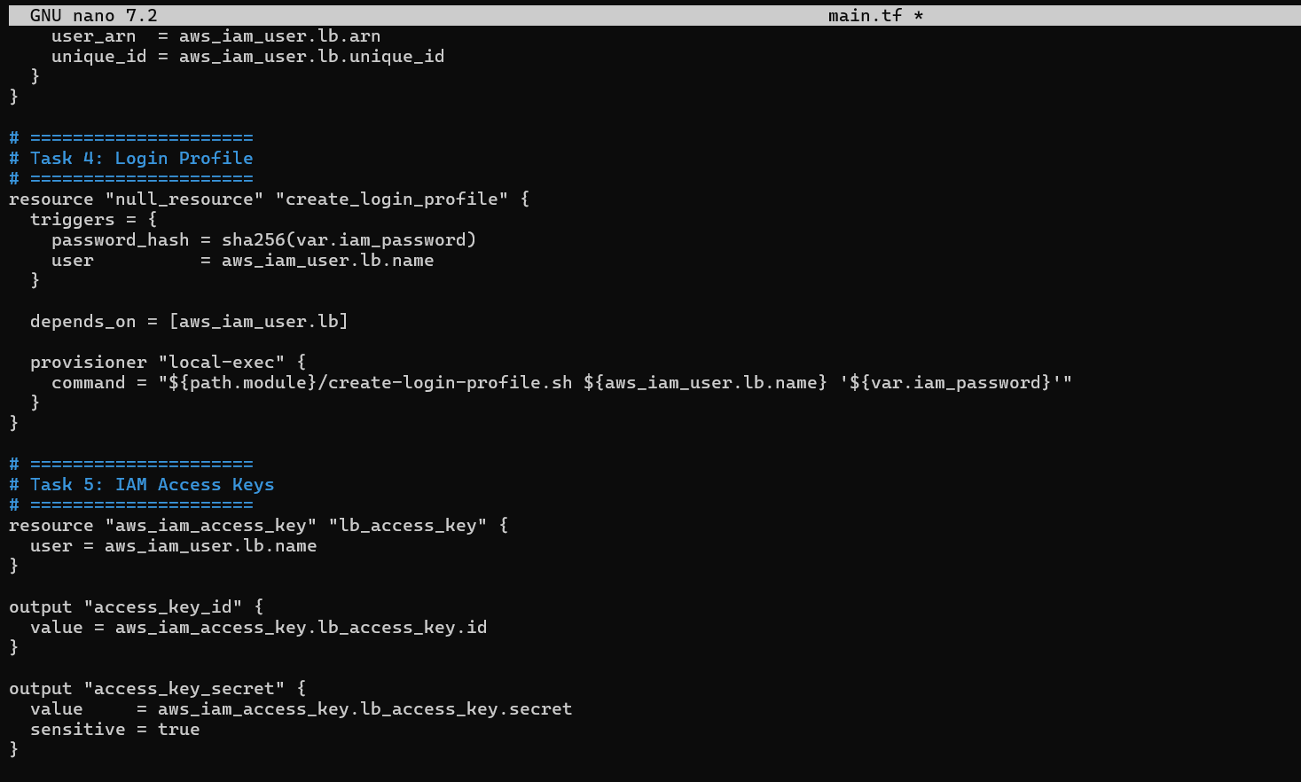
- task5_terraform_apply.png
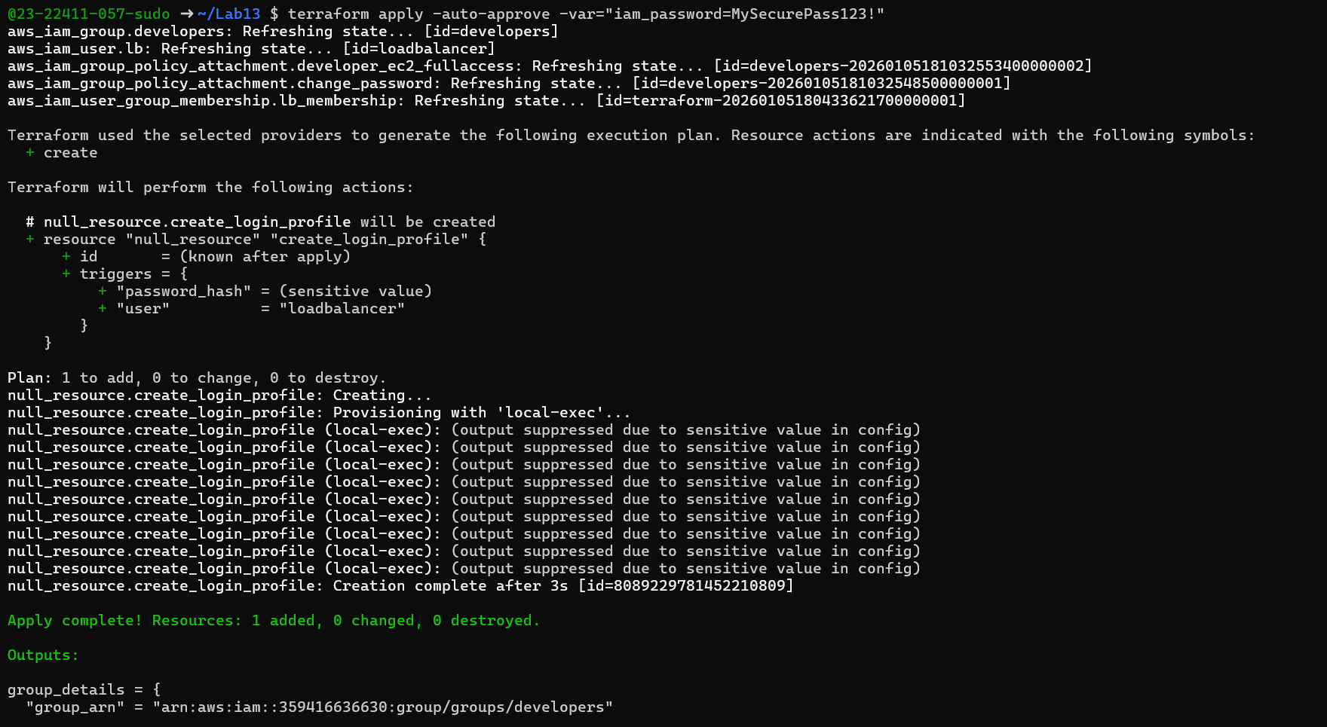
- task5_terraform_output.png
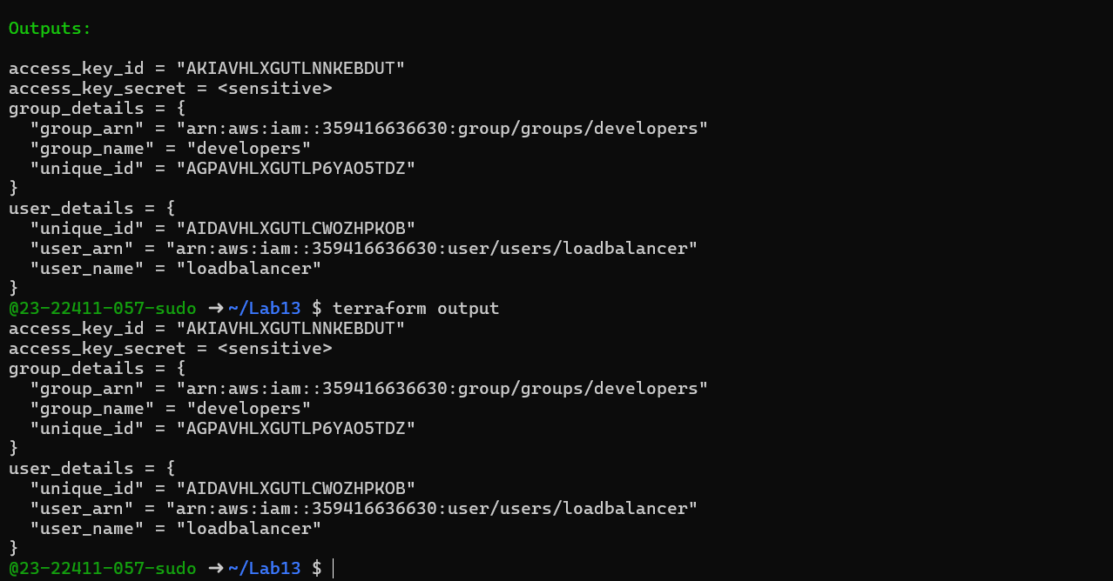
- task5_tfstate_secret. Png
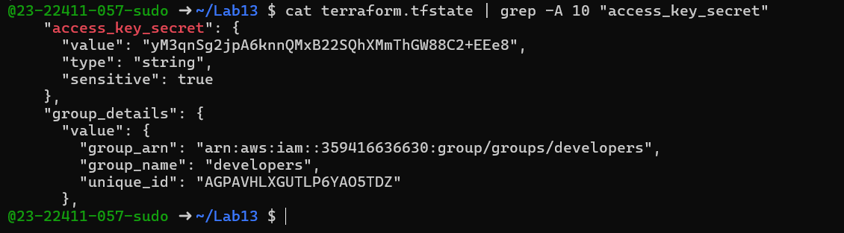
- task5_aws_console_access_keys. Png
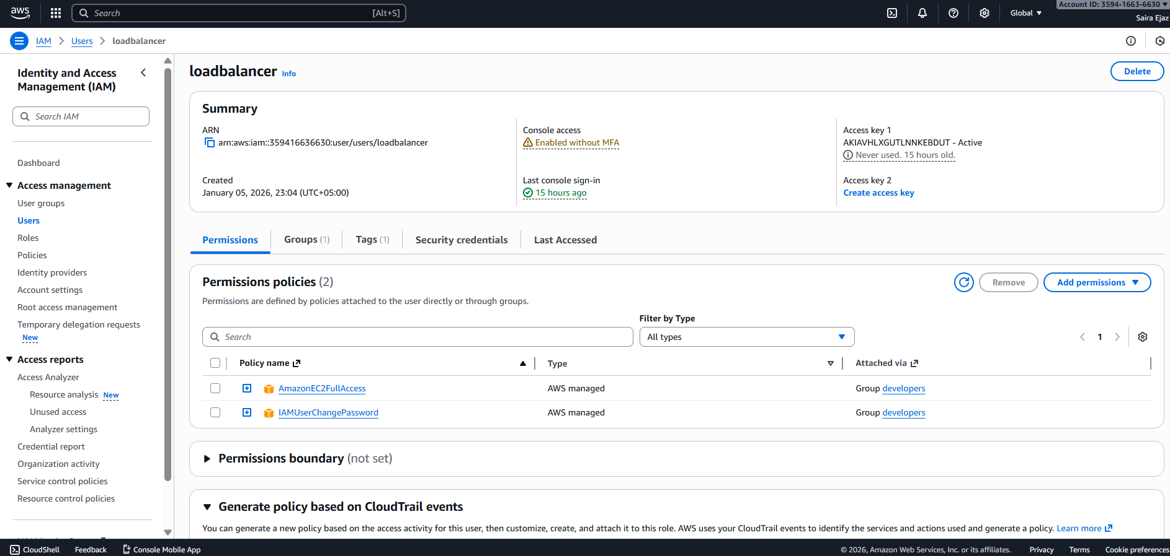
Task 6 — Implement Terraform Remote State with S3
- task6_s3_bucket_create.png
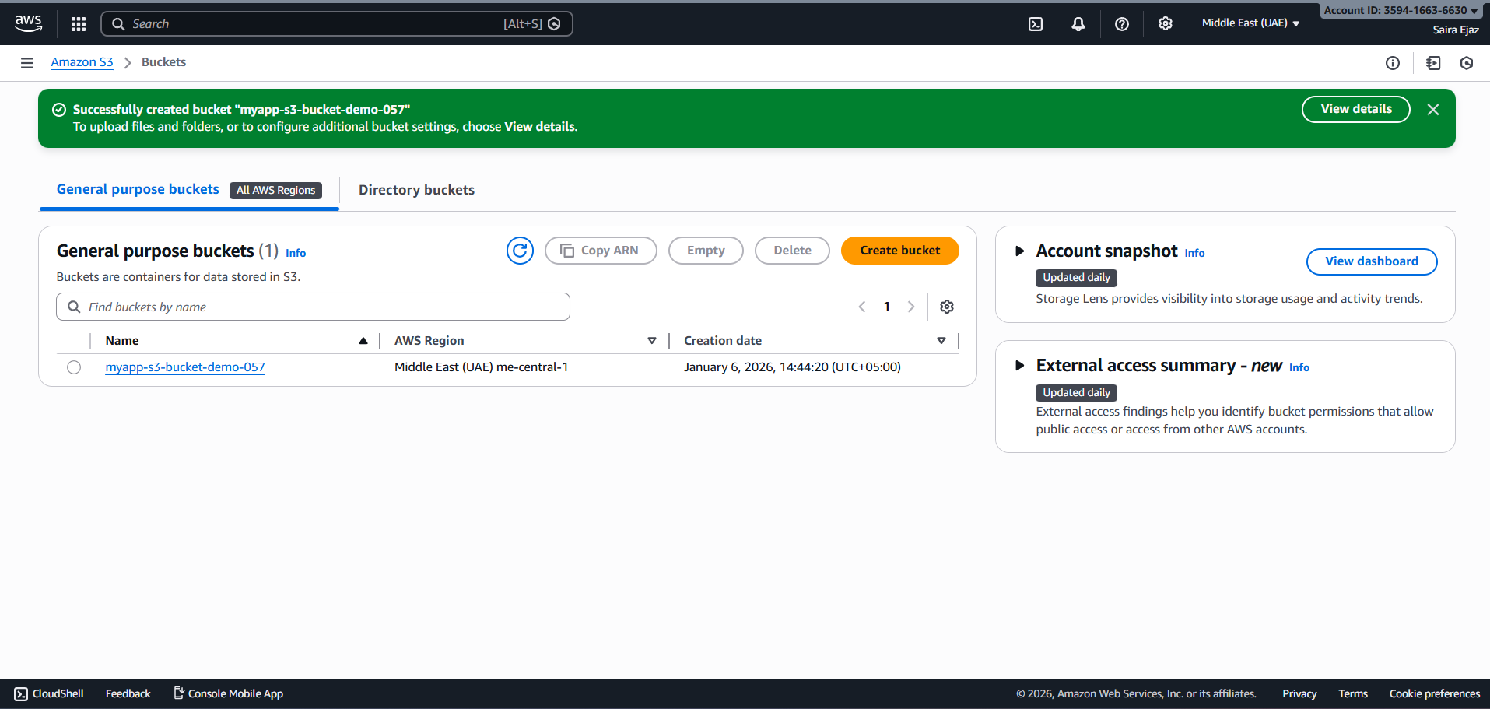
- task6_s3_bucket_versioning.png
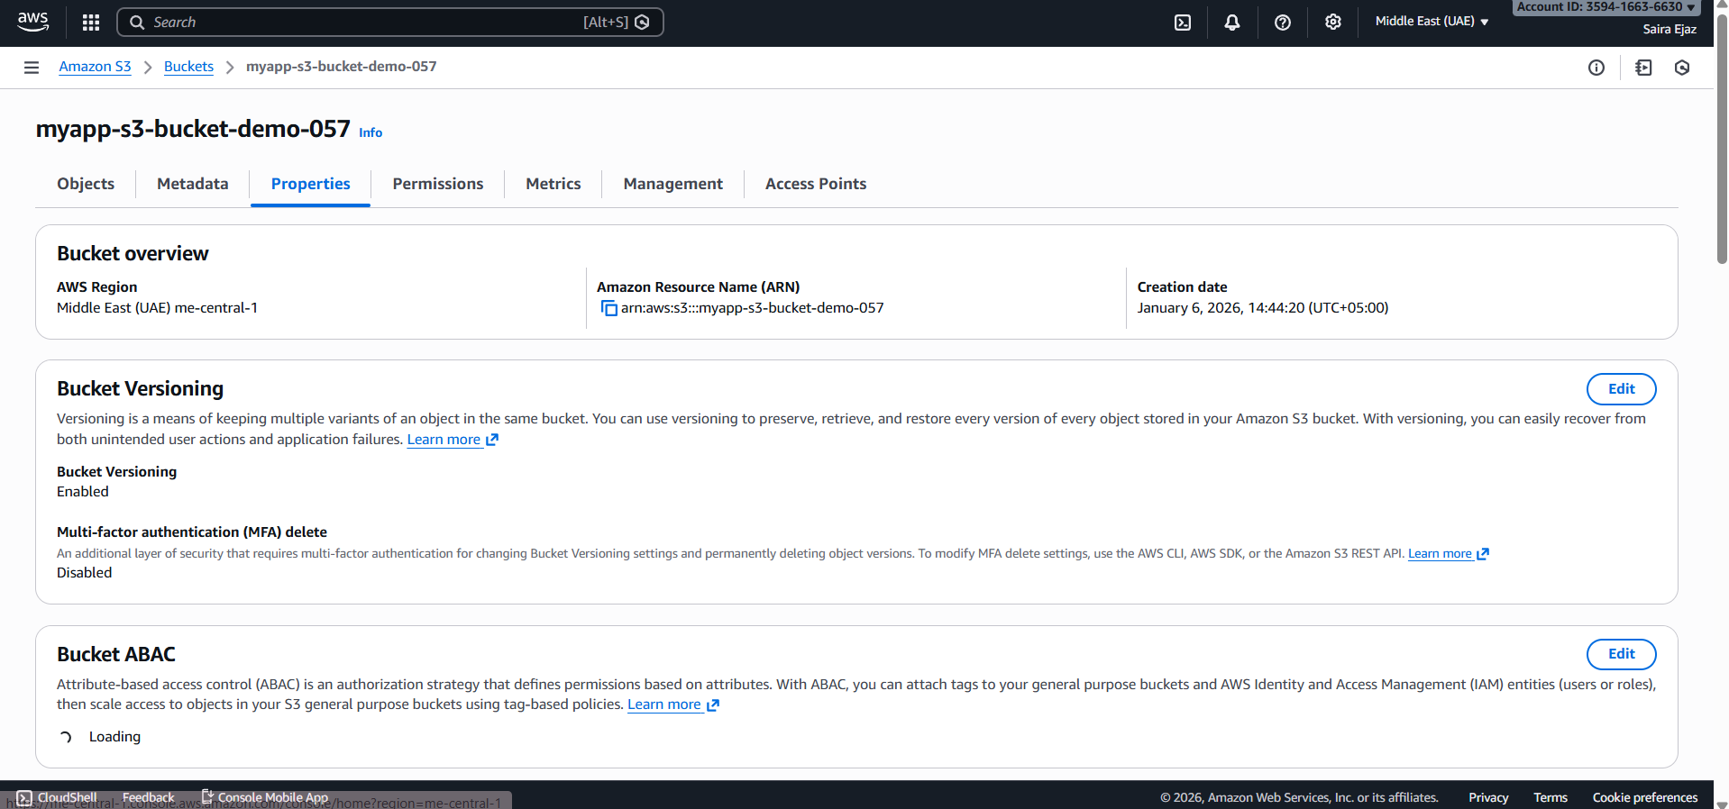
- task6_main_tf_backend.png
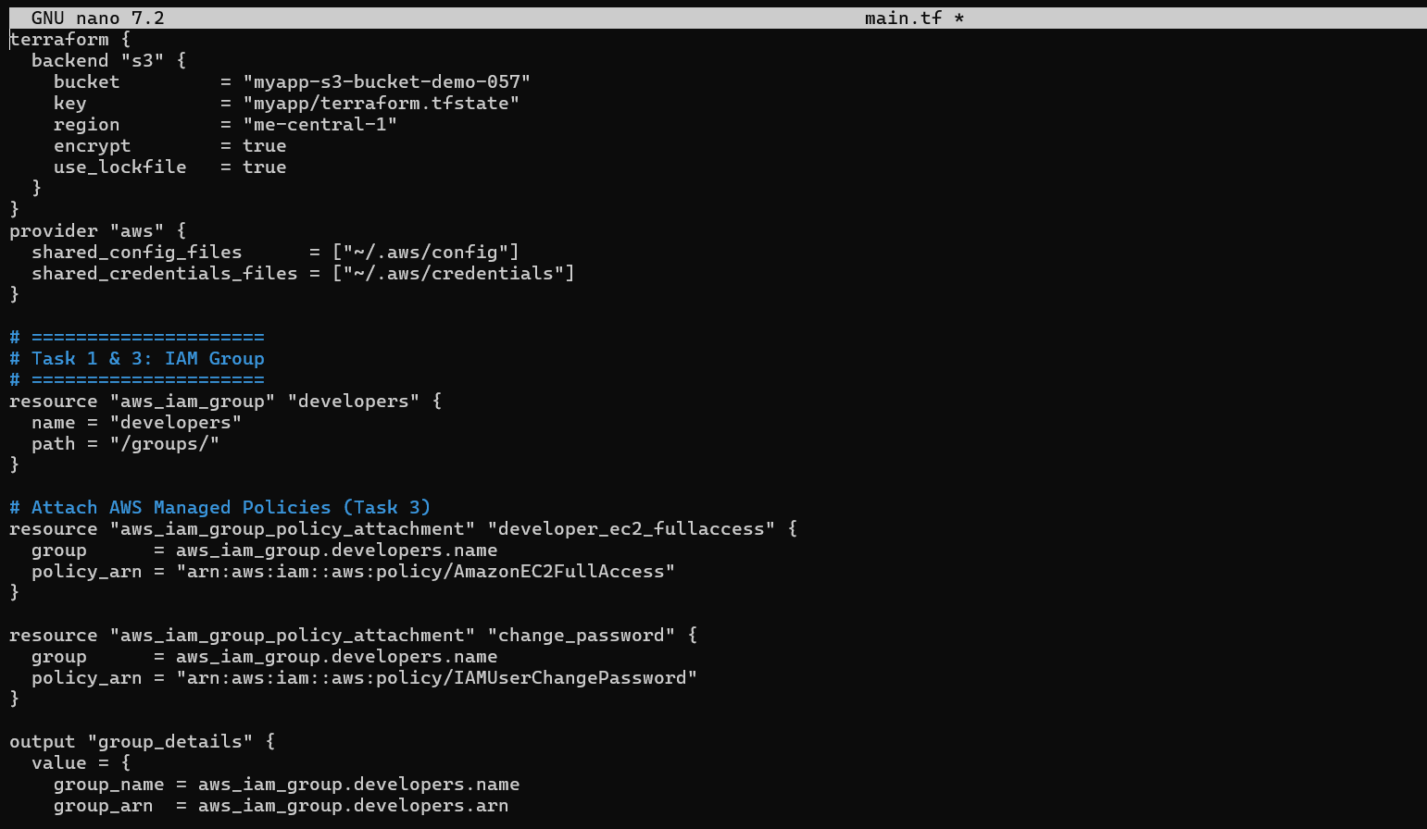
- task6_terraform_init_migrate.png
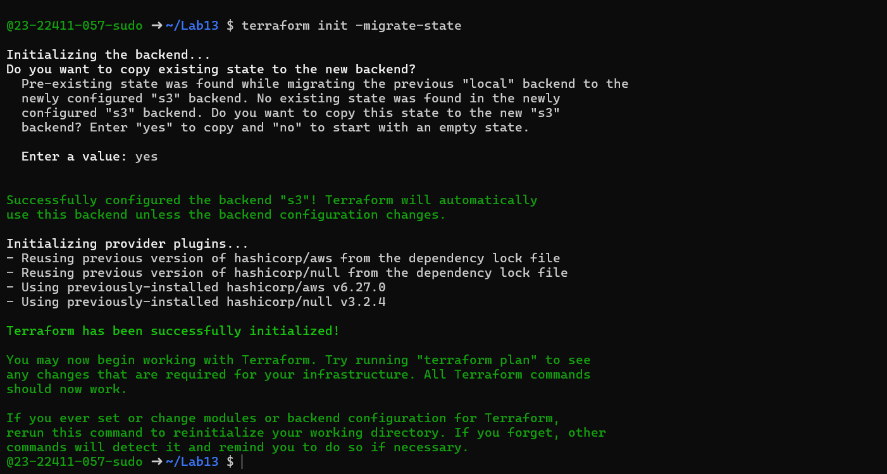
- task6_terraform_apply.png
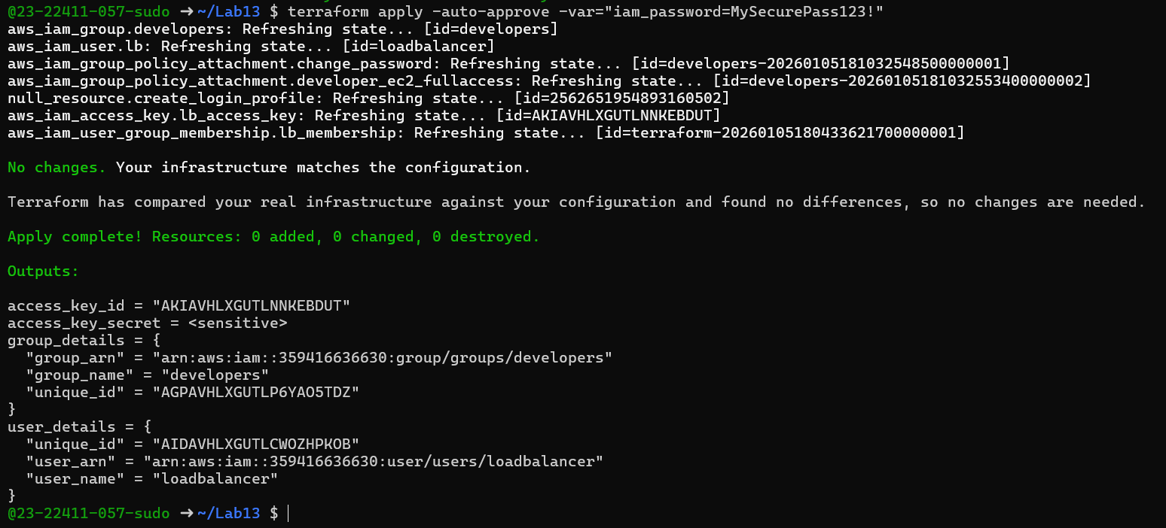
- task6_s3_tfstate_file.png
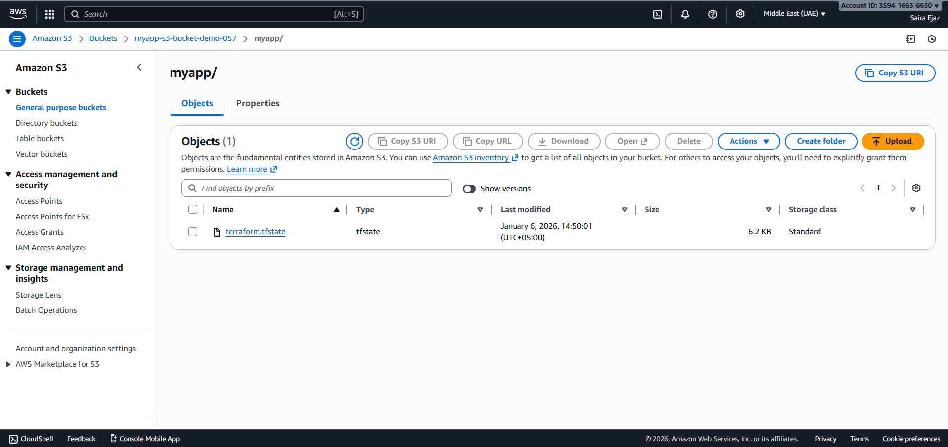
- task6_local_state_backup.png
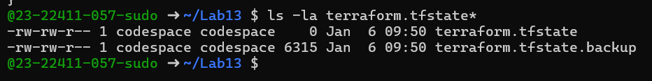
- task6_terraform_destroy.png
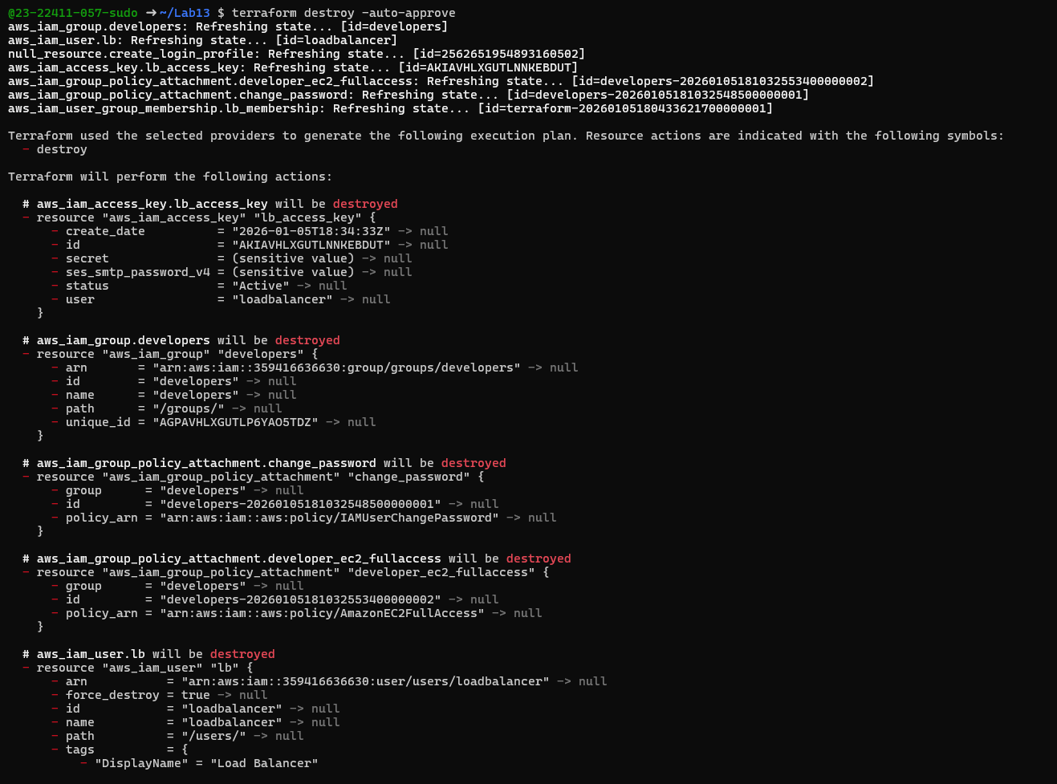
- task6_s3_tfstate_destroyed. Png
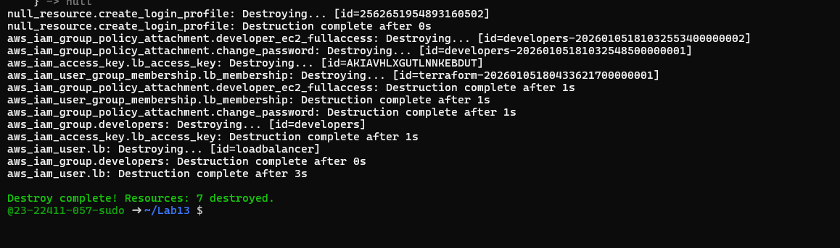
- task6_s3_tfstate_destroyed. png

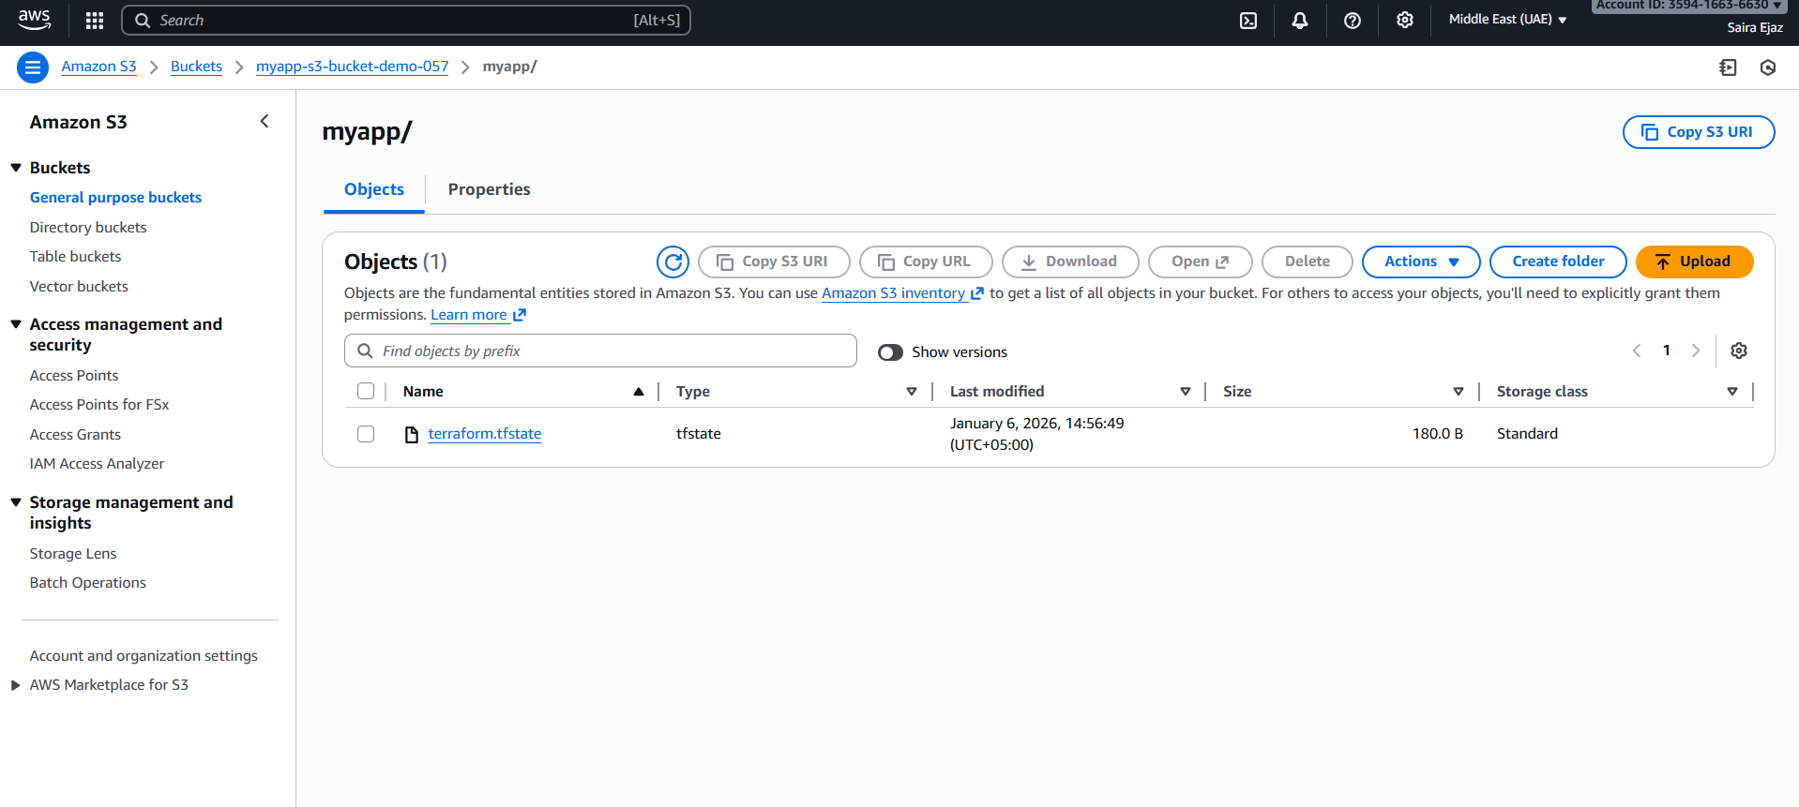
Task 7 — Create Multiple Users from CSV File
- task7_locals_tf.png
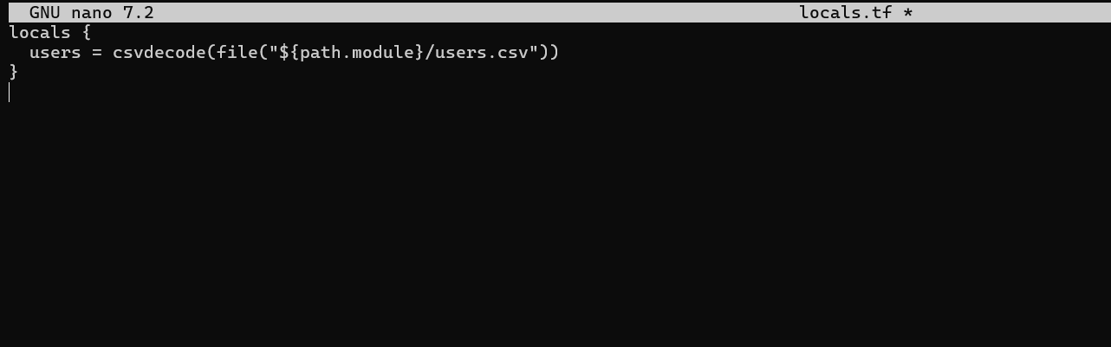
- task7_users_csv.png
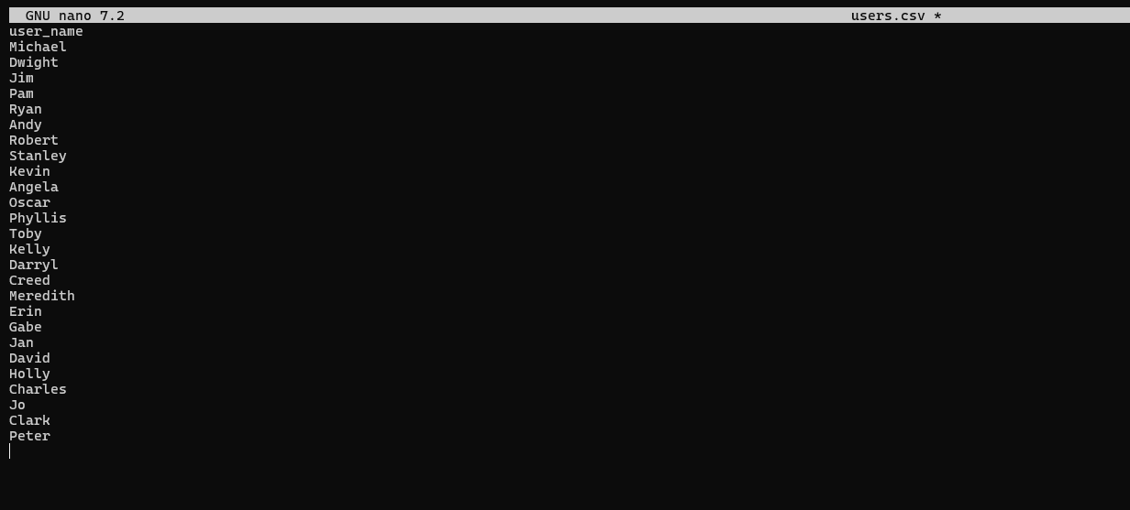
- task7_main_tf_multiple_users.png
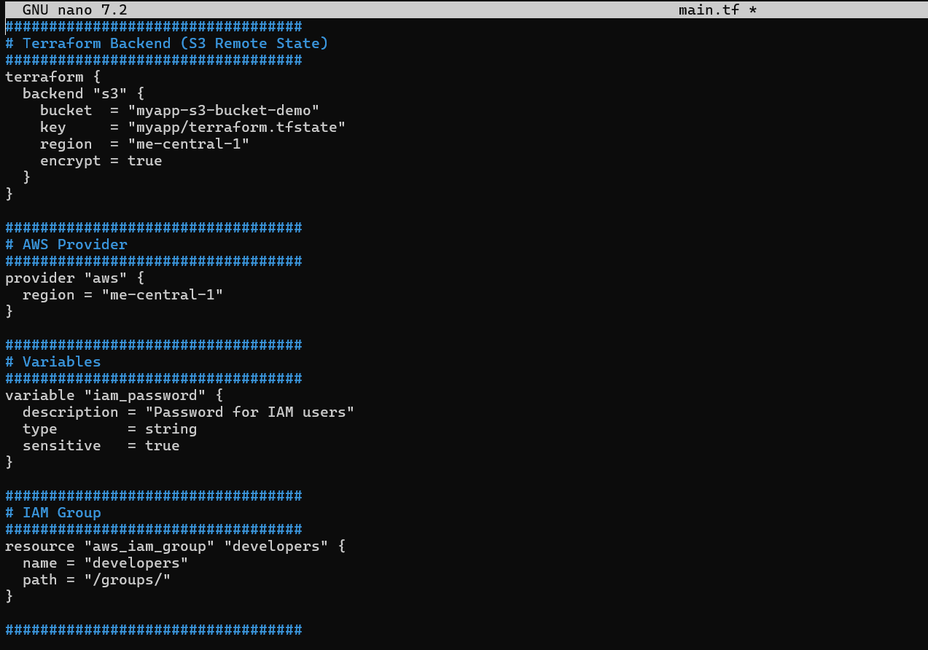
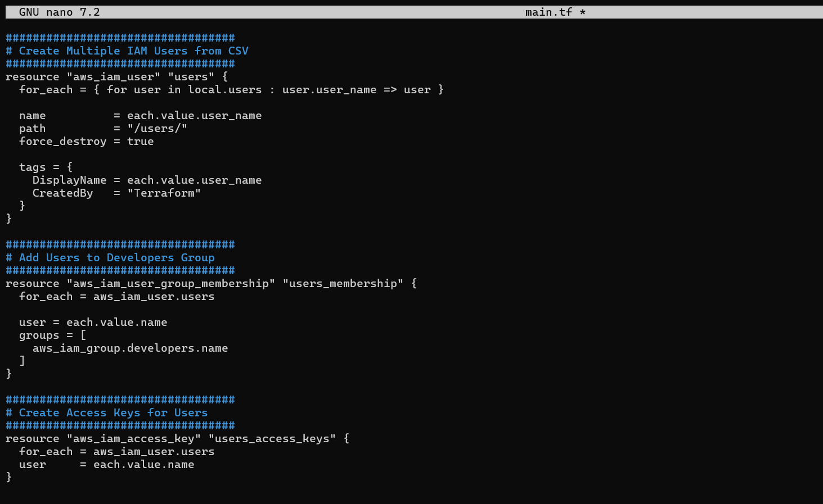
- task7_terraform_init.png
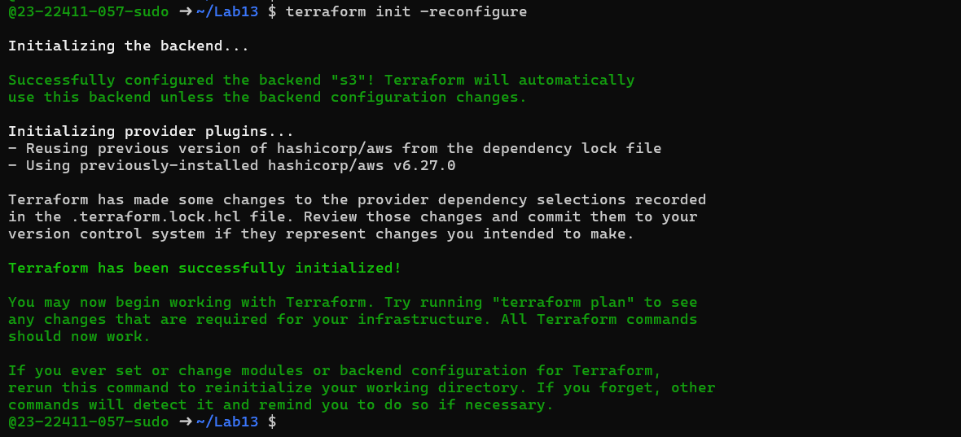
- task7_terraform_apply.png
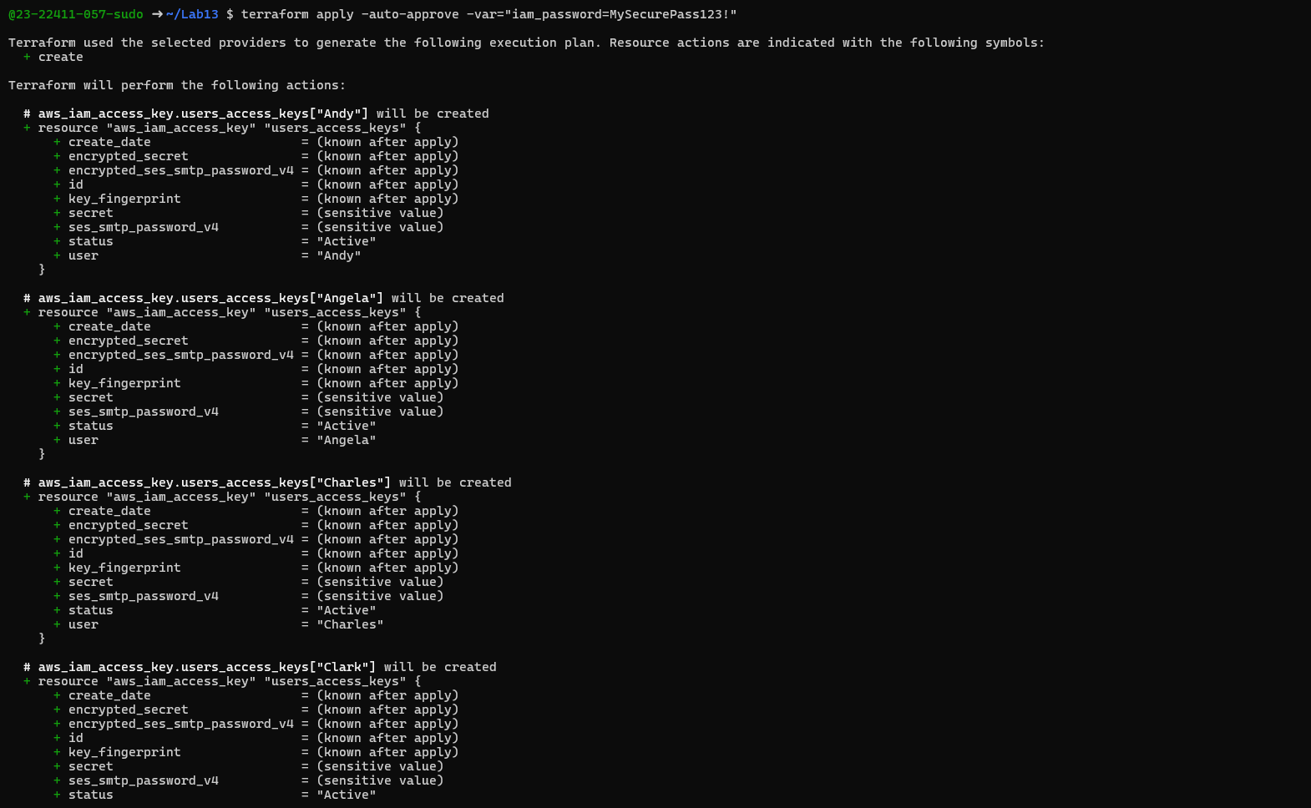
- task7_terraform_output.png
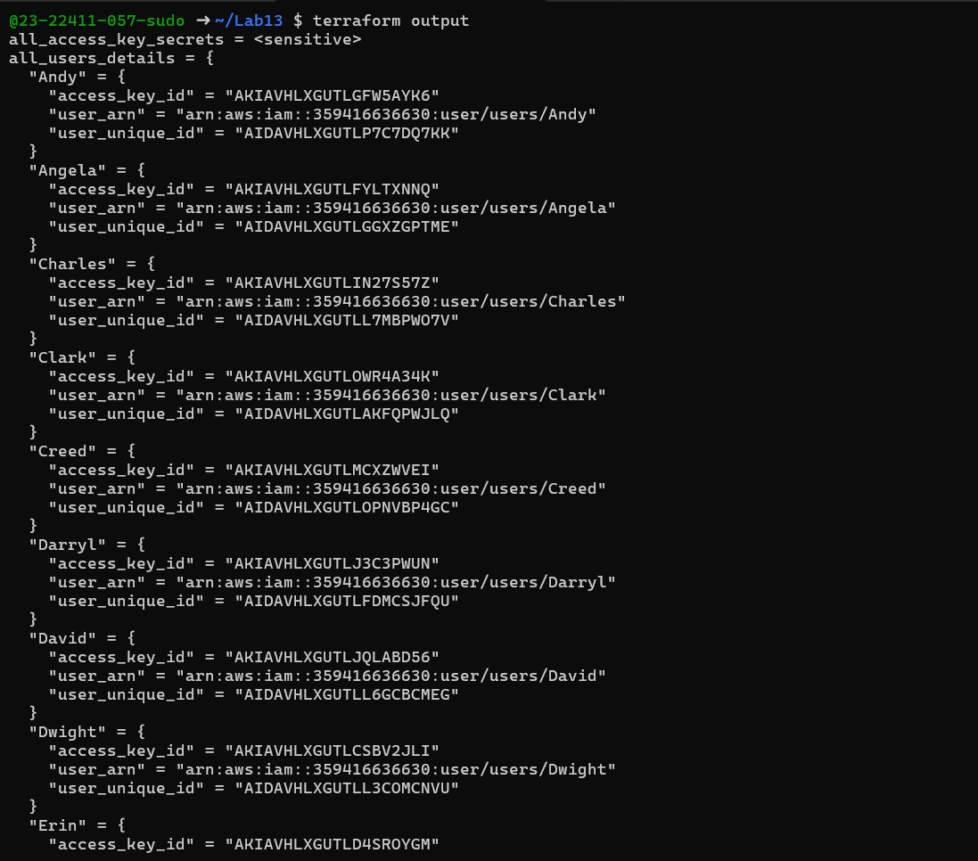
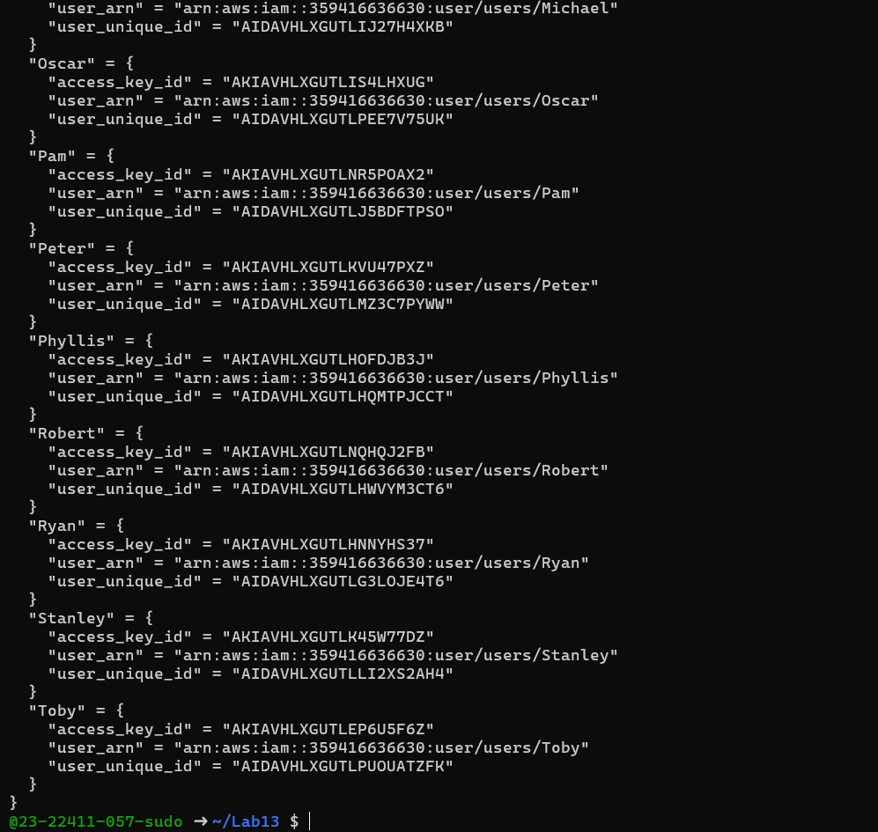
- task7_tfstate_secrets. Png
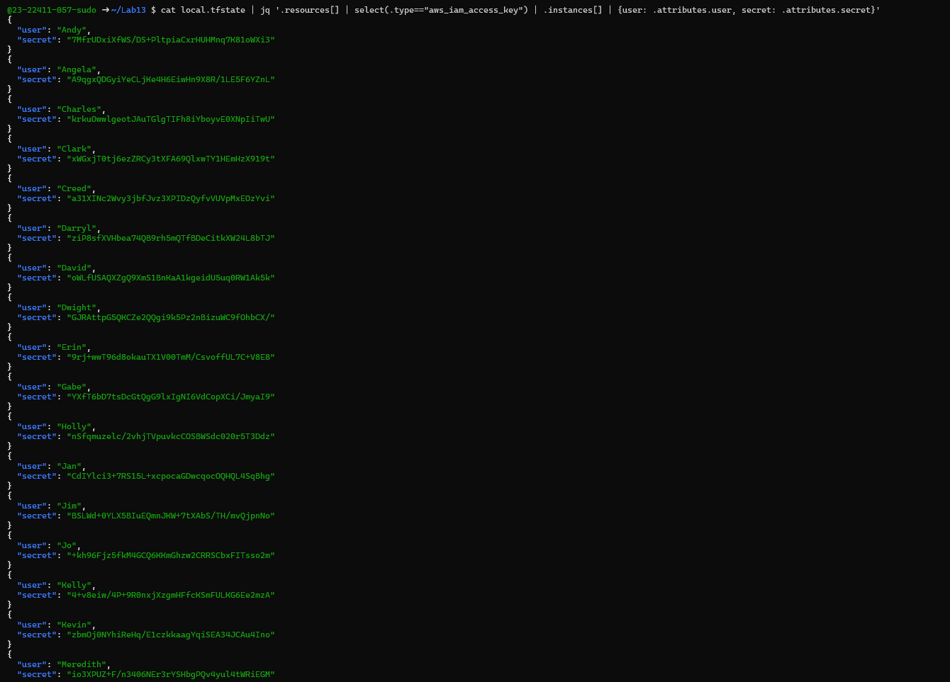
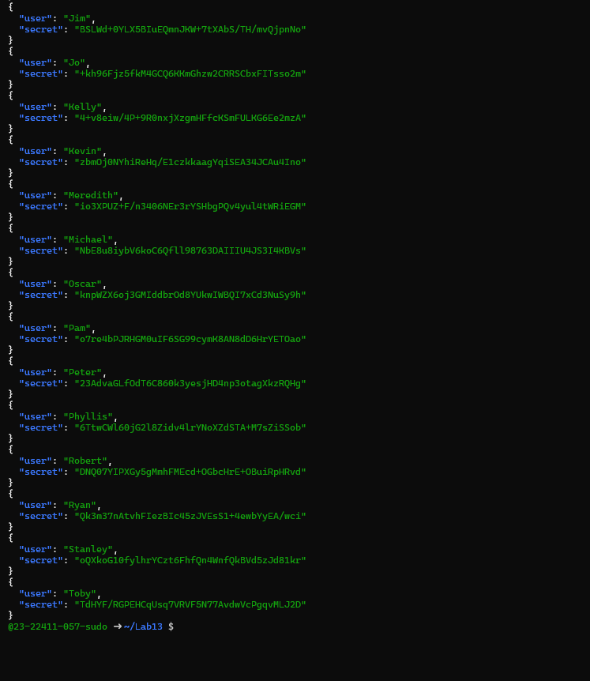
- task7_aws_console_all_users. Png
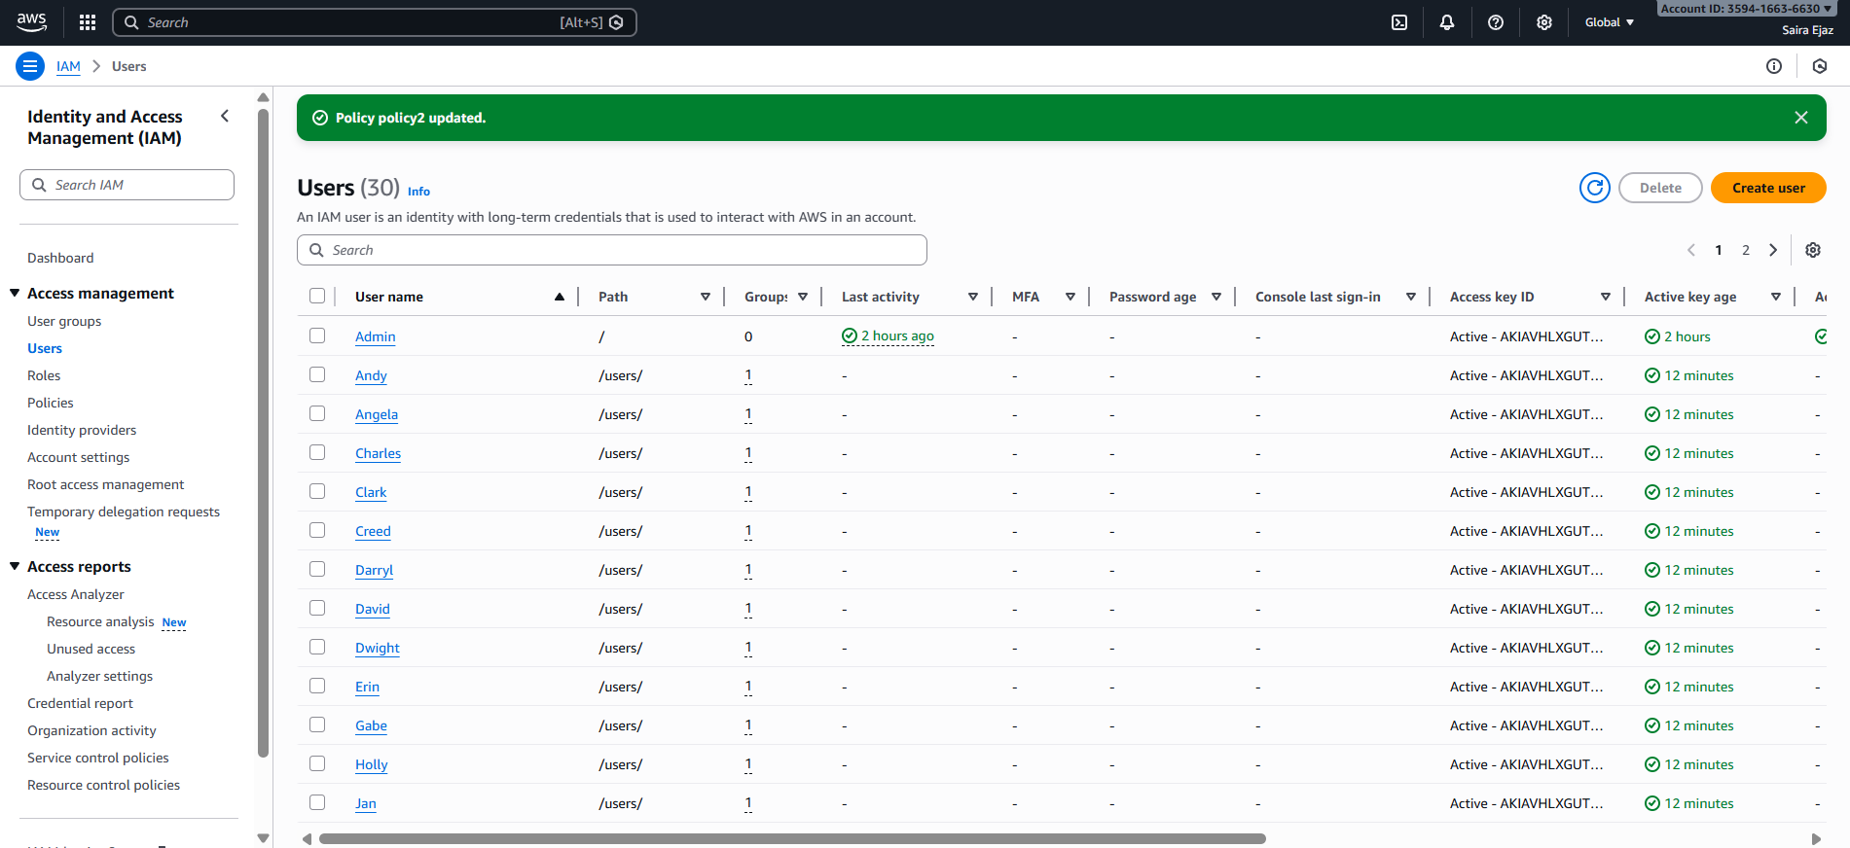
- task7_aws_console_group_members. Png
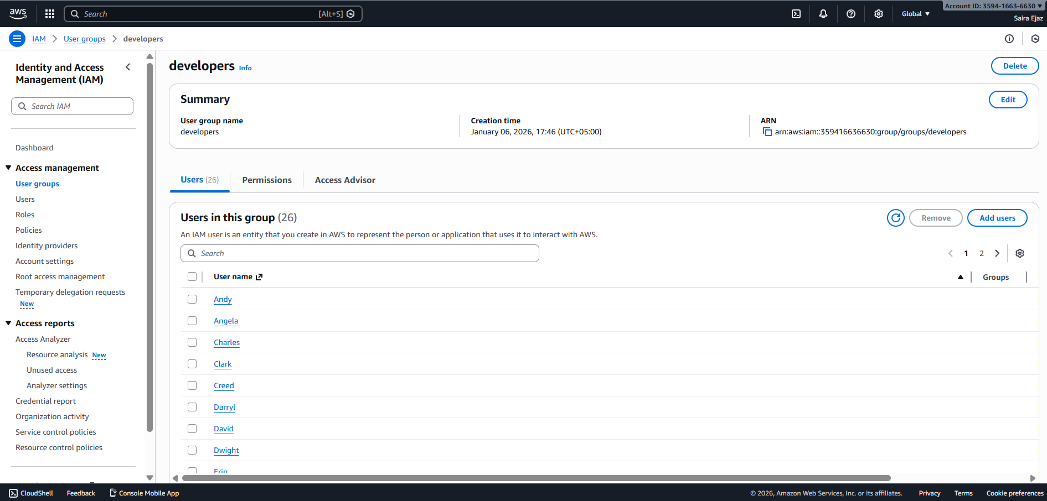
- task7_aws_console_user_access_key.png
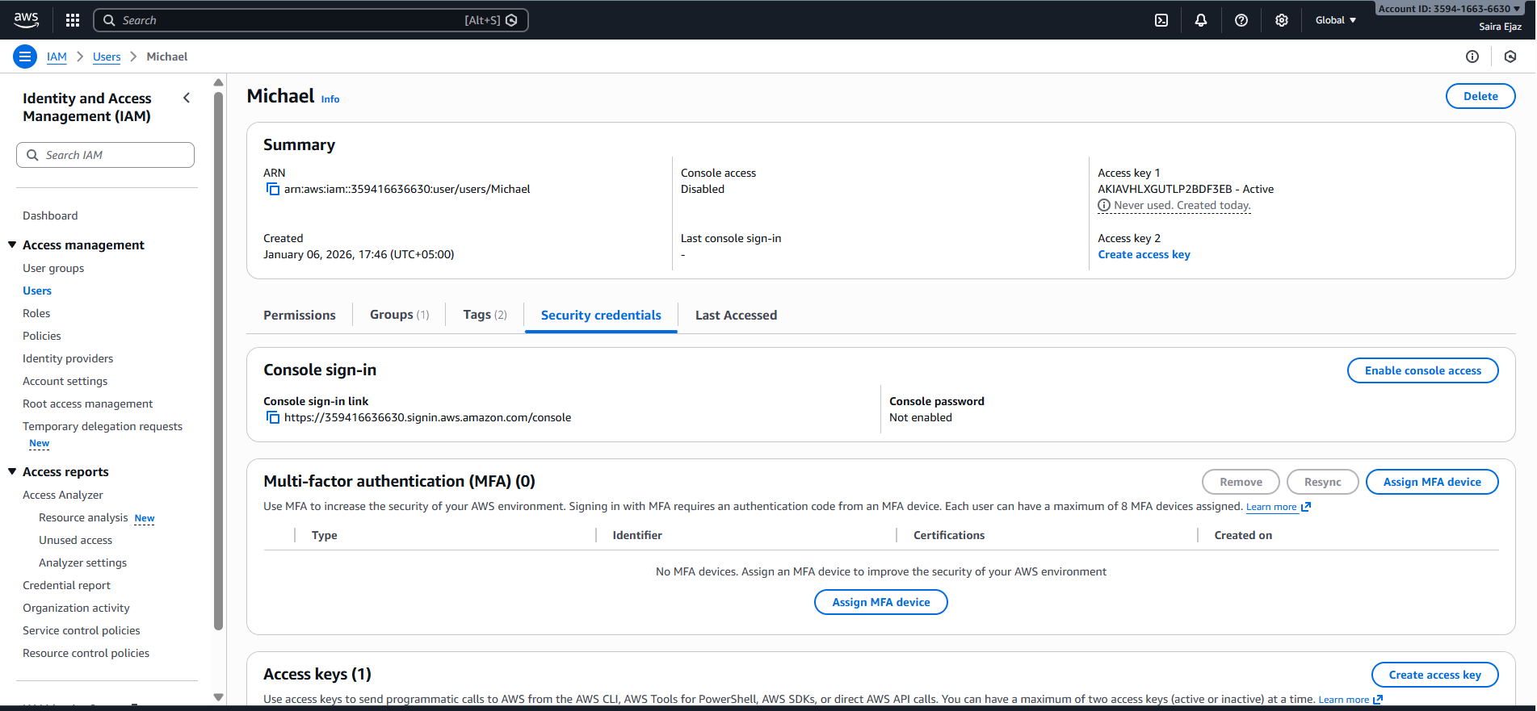
- task7_s3_tfstate_multiple_users.png
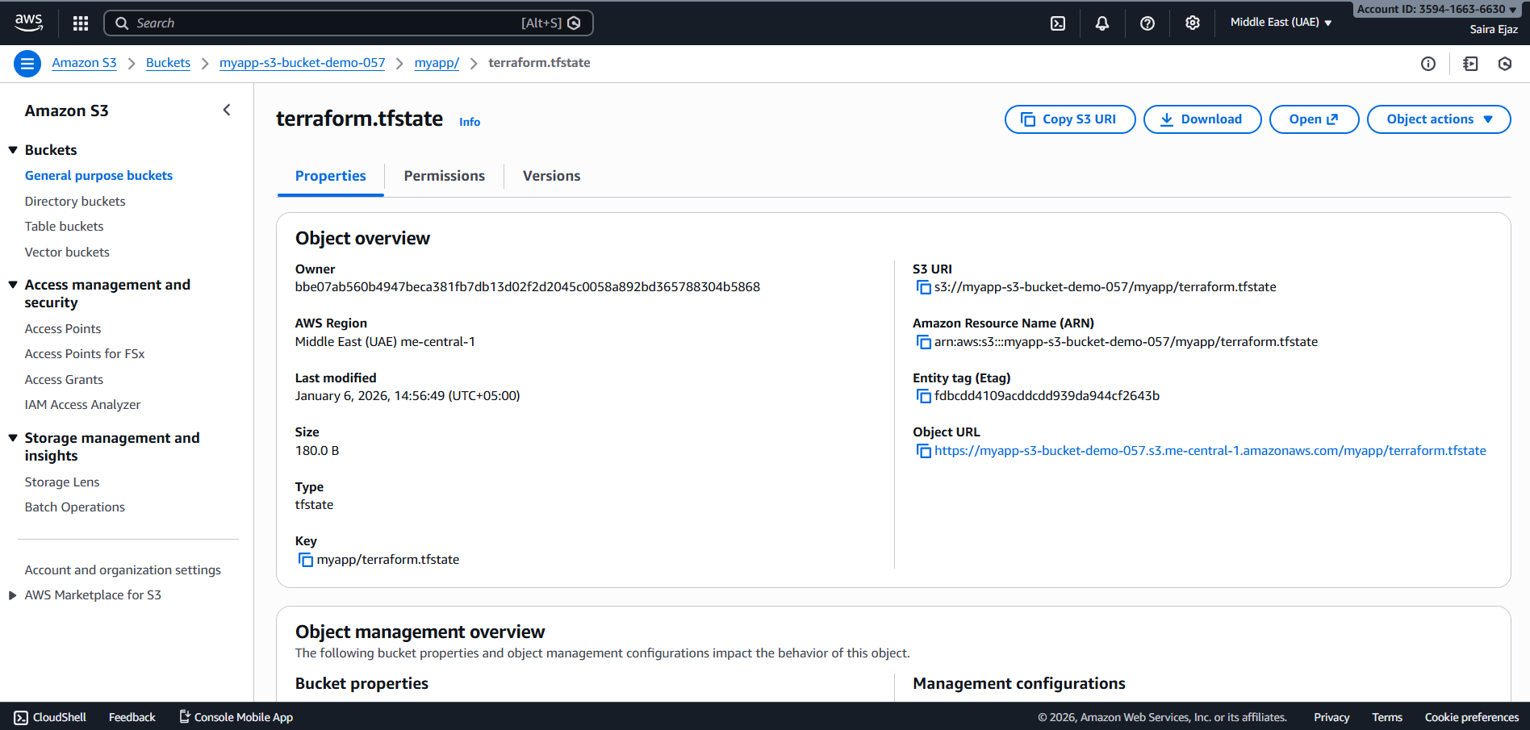
Cleanup
- cleanup_destroy_complete.png
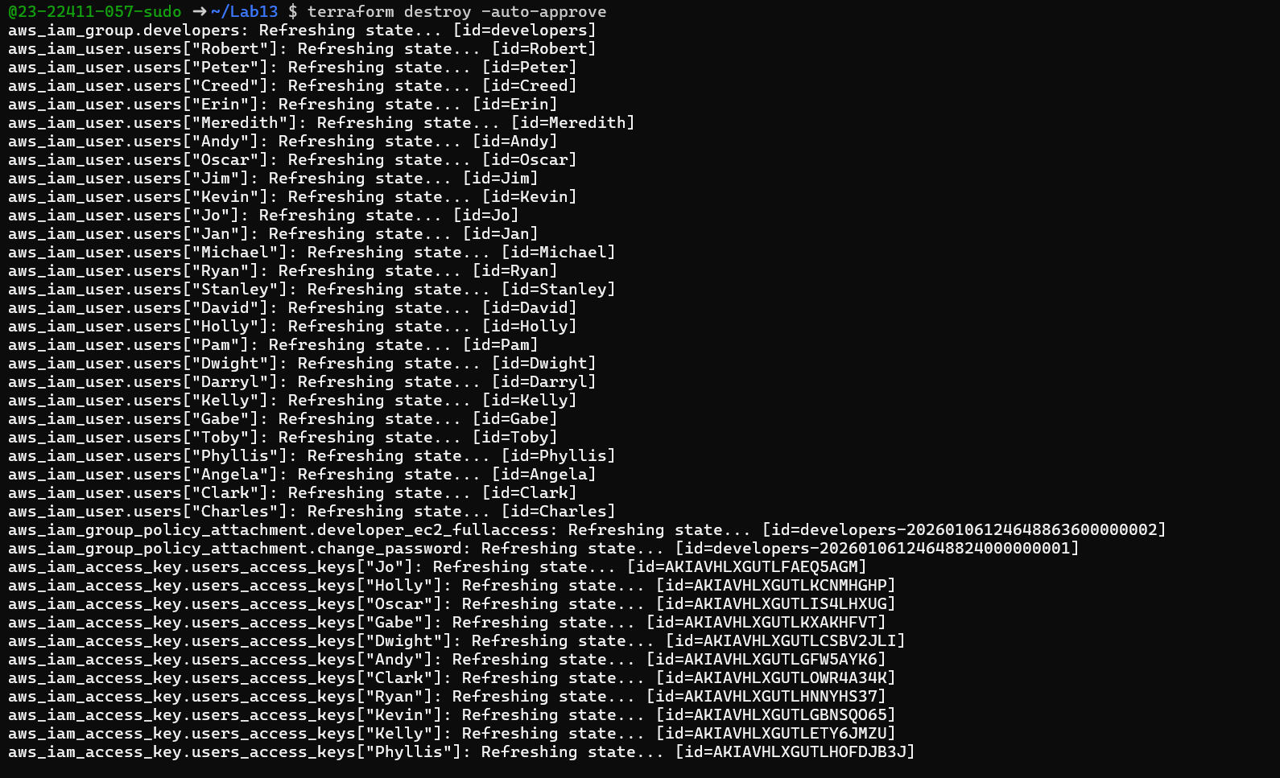
- cleanup_aws_console_users_deleted.png
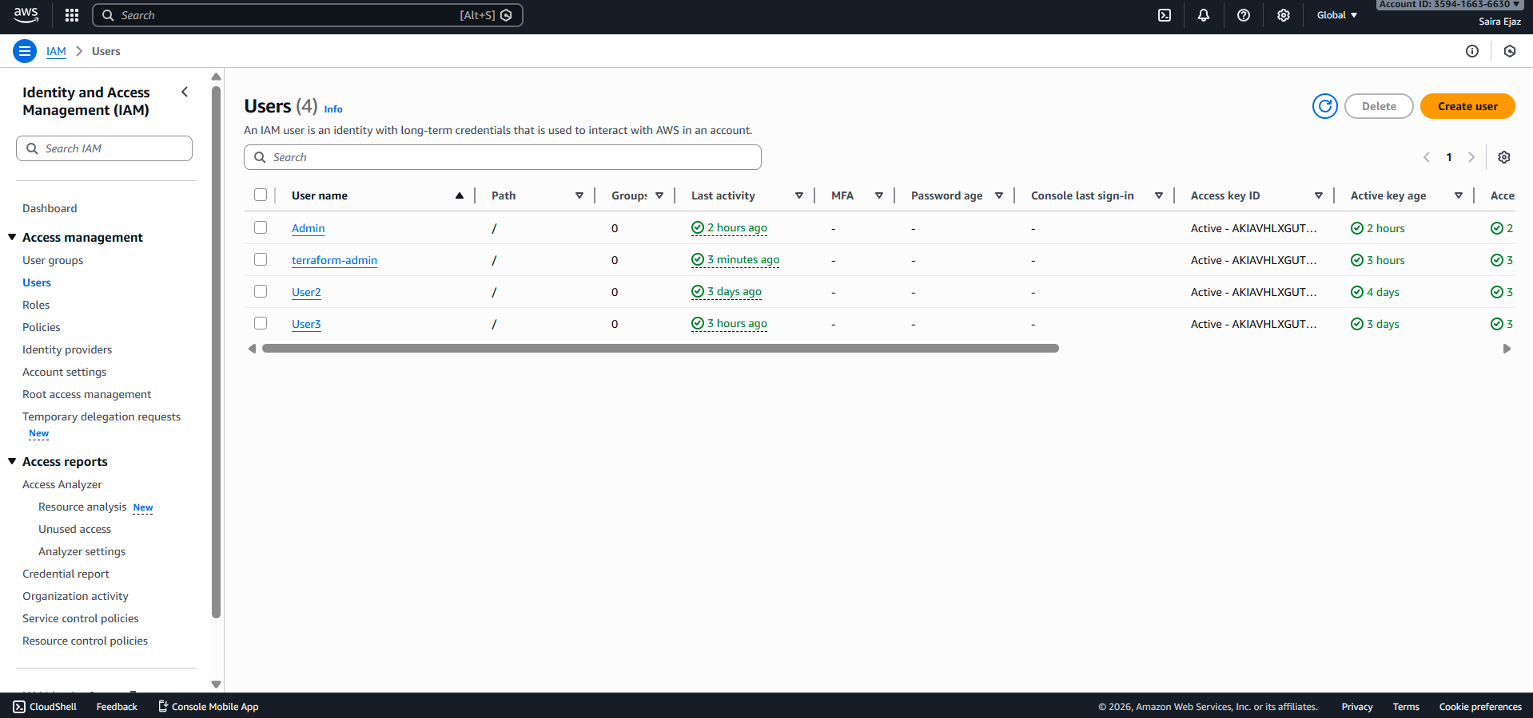
- cleanup_aws_console_group_deleted.png
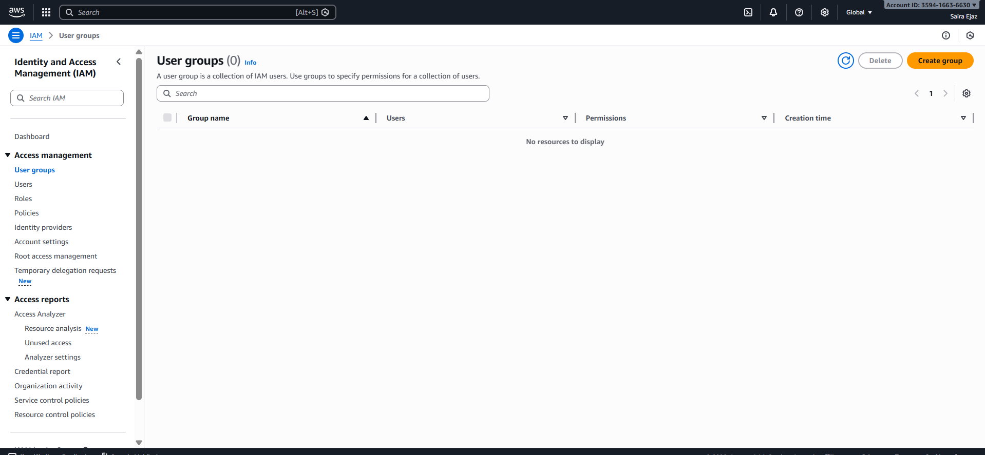
- cleanup_s3_empty_state.png
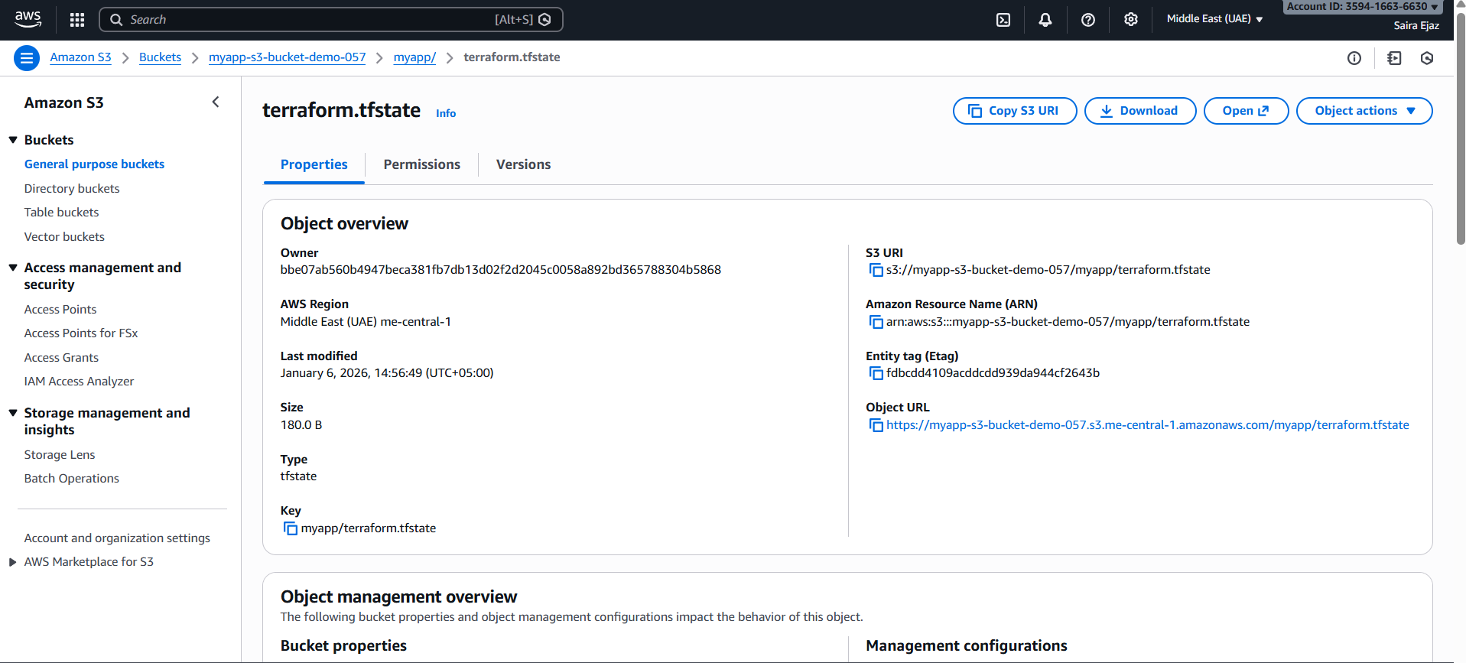
- cleanup_final_files.png
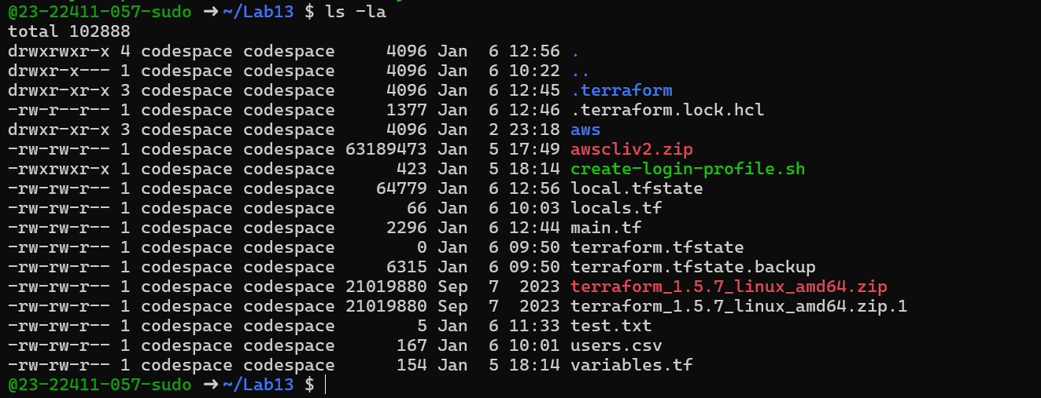
- cleanup_s3_bucket_deleted.png (optional)
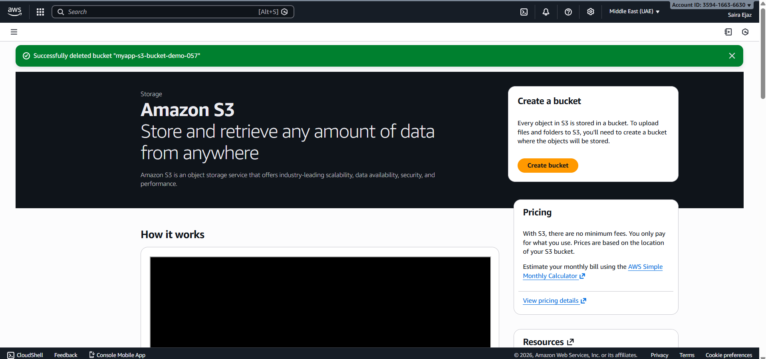
Repository Link
https://github.com/23-22411-057-sudo/Lab13

